COMPREHENSIVE PLAN

SCHENECTADY COUNTY, NEW YORK

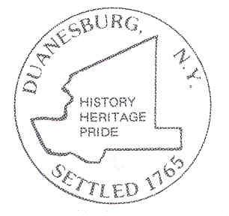

Last Revised December 2, 2020
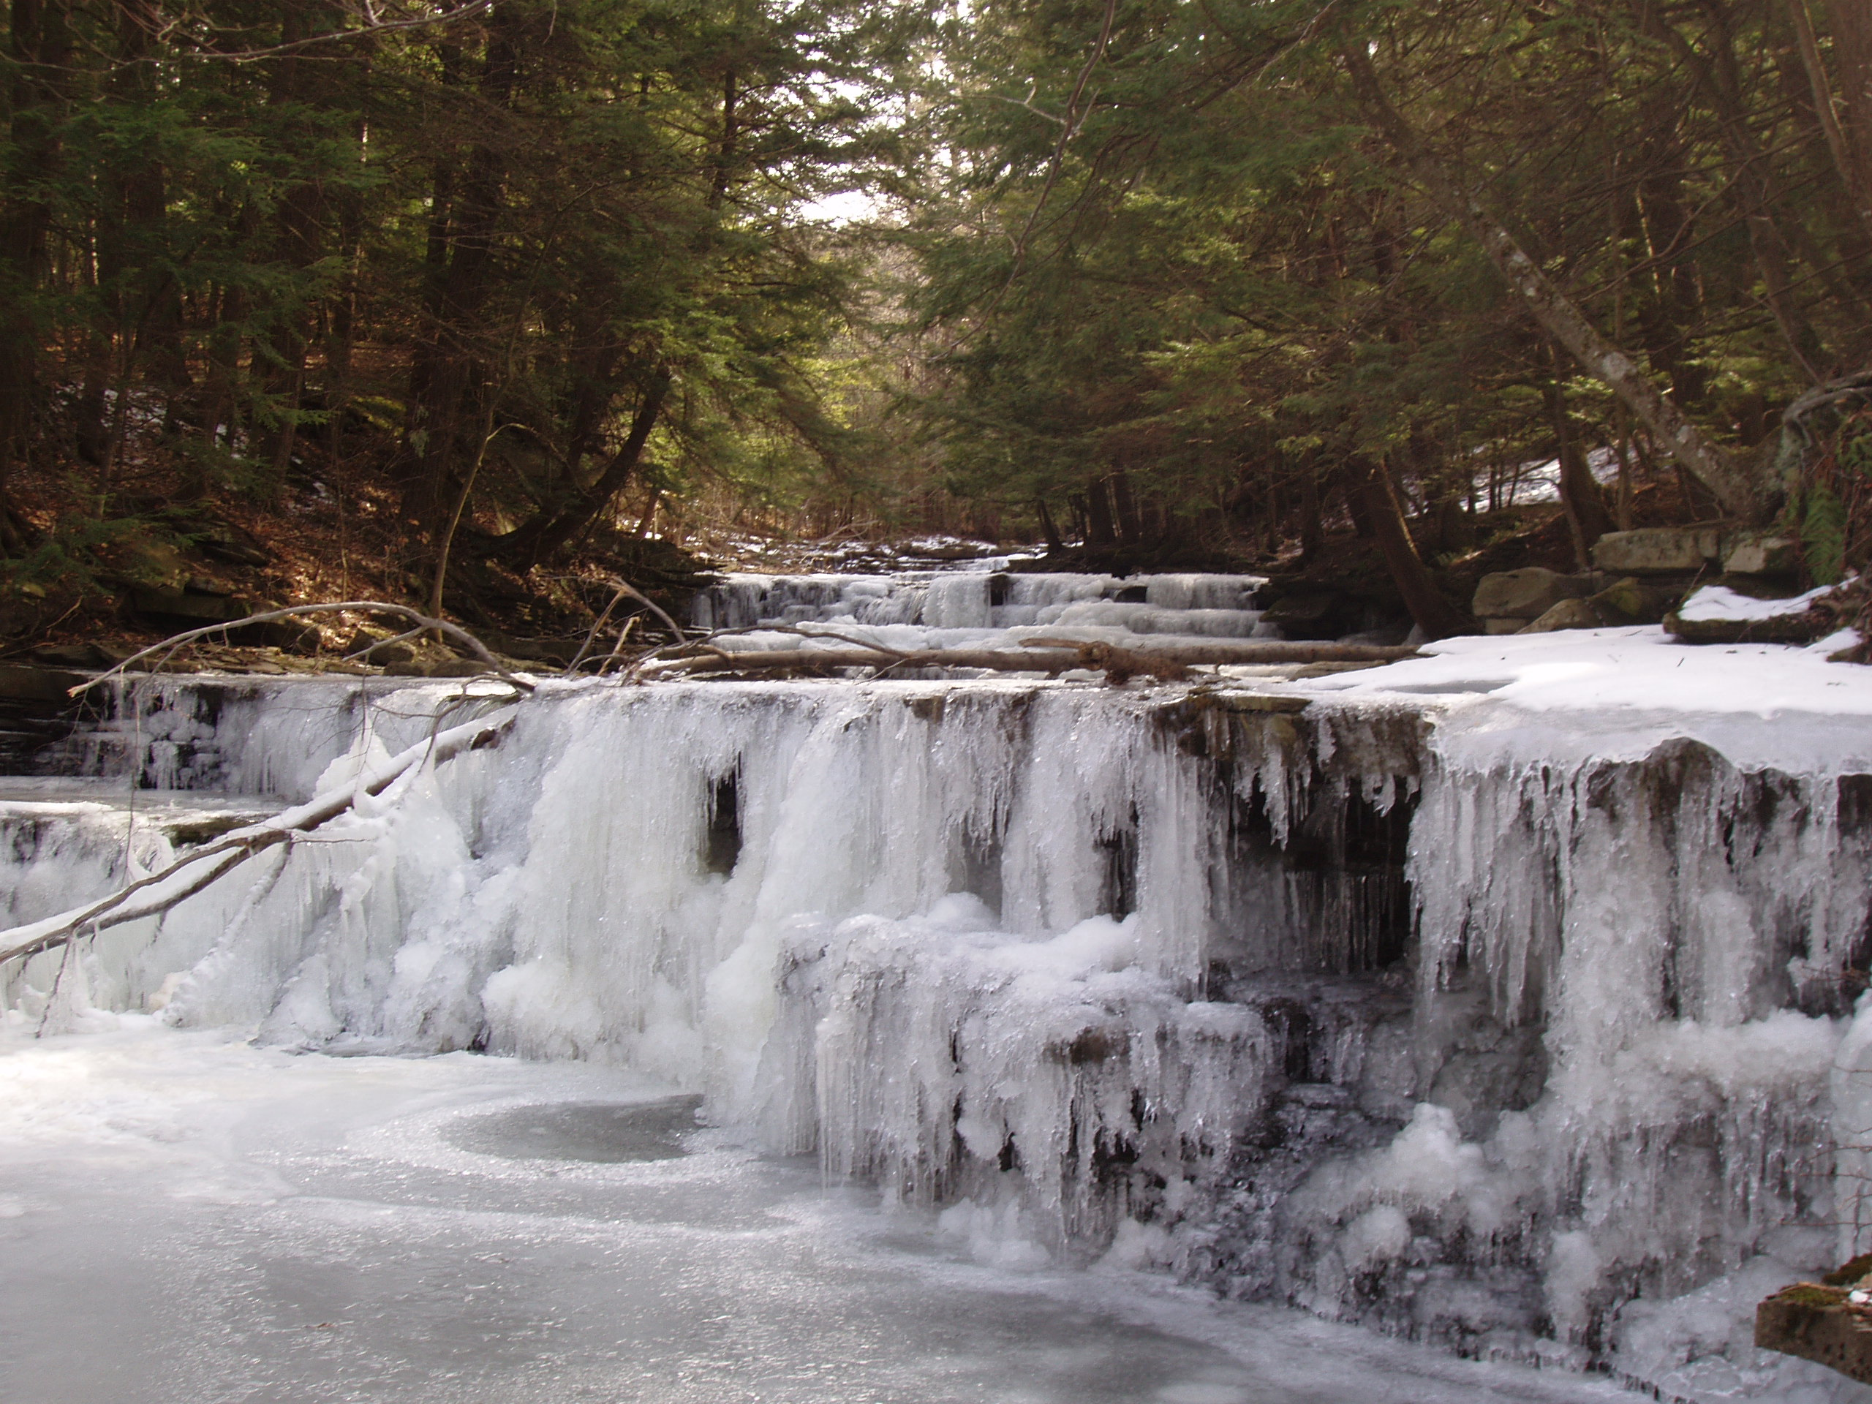Town of Duanesburg Comprehensive Plan

Town of Duanesburg Vision Statement

The Town of Duanesburg is a proud community of strong heritage and rural character. We encourage the preservation of our attractive and cultural landscape. We provide economically vibrant commercial and retail zones, and a variety of quality housing, cultural and recreational options. We are committed to sustaining our valuable economic and natural resources, particularly agricultural land use, open spaces, natural habitats, and fresh watersheds. We support thoughtful growth and development that enable affordable taxes, enhances the character of commercial and residential zones, improves our schools, and provides local business and employment opportunities.

ACKNOWLEDGEMENTS

Duanesburg Town Board

Roger Tidball, Supervisor
John Ganther, Deputy Supervisor and Council Member
Francis R. Potter, Council Member
Jeff Senecal, Council Member
William Wenzel, Council Member

Town Planning Board / Comprehensive Plan Update Committee
Phill Sexton, Planning Board Chair and Comprehensive Plan Update Chair
Jeffery Schmitt, Planning Board Vice Chair
John Ganther, Deputy Town Supervisor
Elizabeth Novak, Planning Board Member
Michael Harris, Planning Board Member
Joshua Houghton, Planning Board Member
Martin Williams, Planning Board Member
Thomas Rulison, Planning Board Member
Nelson Gage, Zoning Board Chair
Dale Warner, Town Planner and Building Inspector
Terresa Bakner, Town Counsel

Table of Contents

INTRODUCTION 6
Town of Duanesburg Vision Statement 6
Previous Plans 6
Why update the Comprehensive Plan? 6
What is a Comprehensive Plan? 6
The Comprehensive Planning Process 7
How is the Plan Implemented? 7
Flexibility Within the Plan 8
A Brief History of Duanesburg 8

DUANESBURG TODAY 9
Physical Characteristics 9
Physiography, Geology and Soils 9
Water Resources 9
Flora & Fauna 12
Utilities 13
BROADBAND 18
Transportation 19
Historic Resources 19
Police, Fire and Ambulance Services 20
Public Parks and Recreation Facilities 22
School District 24
Population Characteristics 25
Population Changes and Projections 25
Regional Population Growth 25
Town Population & Projections 26
Development Trends 28
Housing/Household Characteristics 29
Land use 29
Natural & Manmade Hazards 31
Natural Hazards 31
Manmade Hazards 31
Agriculture 31
Economic Development 37
Household Survey Results 37

GOALS, OBJECTIVES & RECOMMENDATIONS 38
Land Use 38
Housing 39
Commerce and Industry 40
Community Development 42
Natural Resources 46
ADMINISTRATION 50
INFRASTRUCTURE 50
LAND USE PLAN 51
IMPLEMENTATION 55

List of Tables

Table 1. Town Population Change (1980-2040) 26

Table 2. Primary School Age Population (5-19 yrs.) 26

Table 3. Travel Time to Work (Percent of Residents) 27

Table 4. Population Distribution by Age Group (2000) 27

Table 5. Land Use (Number of Parcels & Assessed Value) 30

Table 6. Revenues & Expenditures FY 2003 30

List of Figures

Figure 1. Conservation Subdivision Example 45

Figure 2. Watercourse Buffer 47

List of Maps

Map 1. Water Resources………………………………………………………………………. 11

Map 2. Sewer Districts………………………………………………………………………....15

Map 3. Delanson/Duanesburg Reservoir Watershed…………………………………………. 17

Map 4. Historic Resources………………………………………………………………….… 21

Map 5. Parks/Open Space………………………………………………………………….…. 23

Map 6. Agricultural District……………………………………………………………….….. 36

Appendices

Household Survey Results 57

Summary of Public Feedback and Public Hearing Comments 66

INTRODUCTION

Town of Duanesburg Vision Statement

The Town of Duanesburg is a proud community of strong heritage and rural character. We encourage the preservation of our attractive and cultural landscape. We provide economically vibrant commercial and retail zones, and a variety of quality housing, cultural and recreational options. We are committed to sustaining our valuable economic and natural resources, particularly agricultural land use, open spaces, natural habitats, and fresh watersheds. We support thoughtful growth and development that enable affordable taxes, enhances the character of commercial and residential zones, improves our schools, and provides local business and employment opportunities.

Previous Plans
The Duanesburg Town Board adopted a revised / updated Comprehensive Plan in June of 2006. This document further updates the 2006 version, including revisions to the Goals and Objectives as needed, incorporates the recent community survey results, examines existing community facilities (e.g. utilities, parks, emergency services, etc.), updates population data and growth trends, and looks at the potential impacts of regional growth patterns and projections of the community. The update also considers changes in circumstances that may affect the Town associated with a rise in e-commerce and the pandemic of 2020.

Why update the Comprehensive Plan?
The existing Comprehensive Plan is nearly 15 years old and does not necessarily reflect new community concerns or adequately address community growth issues and opportunities. Since the adoption of the 2006 plan there have been many changes to the overall commercial and residential environment of the town. These changes include, for example: 1. growing development and use of the commercial district at the intersections of Rt. 20 and 30, 2. establishment of the Duanesburg Community Center now the Duanesburg YMCA, 3. construction and operation of three new sewer districts, and 4. recent adoption and implementation of a new local solar law and an agritourism law that resulted in the construction of a meadery and a brewery in the Town.

Growth in and of the Town is not expected to stop or slow down. Growth is expected to be managed in a thoughtful and productive manner that supports the Town’s vision. This updated plan provides the road map to ensure that the Town remains a desirable and thriving place to live and work – a Town with appealing neighborhoods, safe & attractive housing, adequate and safe traffic circulation, quality public services, and a pattern of private and public land use which is both desirable and sustainable. Agriculture, an industry, and a way of life, critical to the rural nature of the Town is also changing.

What is a Comprehensive Plan?
The Comprehensive Plan is one part of the land use planning process. The Plan is a public document which is adopted by the Town as a policy guide for making decisions which affect the physical development of the Town. It provides the framework for identifying what the community will look like (goals, objectives, principles), how the community intends to get there (standards, devices, instruments) and the purposes for doing so.

This updated Comprehensive Plan (Plan Update) will serve as a long-range guide for both public and private decisions that influence the community. It will also provide the rational basis to update the zoning and subdivision laws, provide guidance on capital expenditures, and identify the goals, objectives, and policies for the immediate and long-range protection, enhancement, growth and development of the Town.

The Comprehensive Planning Process
The Town Planning Board started the Comprehensive Plan update process in November of 2018 with the establishment of the Town Planning Board as the representative Comprehensive Plan Update Committee. The review and revision process also included the Town Planner, and several members from the Town Board and Zoning Boards. The public at large was invited for all review meeting sessions. Public participation included; a) a written survey mailed to all residences in the Town, b) committee meetings open to the public and conveniently scheduled at Town Hall either immediately before or after the regular Town Planning Board meetings, c) a public comment period, and c) two public hearings. Because the COVID-19 pandemic occurred during the Comprehensive Plan update process, the update required further revision and a longer period for public comment.

This Plan update also incorporates information derived from several other sources including:

- Technical information on demographic, social, and economic characteristics from the US Census Bureau and the Capital District Regional Planning Commission.

- Technical information on transportation systems, community facilities, and environmental characteristics.

- Questionnaire survey of town residents and the comments and recommendations made by town residents in various public meetings held during the 2-year update process; and

- Regional growth patterns and trends.

Using this information, the Plan sets goals that seek to retain and improve existing social and environmental qualities while ensuring that the quality of future development is maximized. These goals can be achieved by providing a coordinated pattern of land uses that regulate the type, density, and location of structures, recreational facilities, open spaces, and planned economic development, including the direction of certain types of future development, such as distribution centers to particular areas of the Town.

How is the Plan Implemented?
The Comprehensive Plan Update is a public document that is adopted by the Town Board as a policy guide to future public and private land use decisions in the Town. The Plan is not, however, self-implementing. To implement the policy decisions in this Plan it will be necessary to update existing land use control mechanisms. These mechanisms include updating:

- The Town zoning ordinance which regulates land use, housing density, and the size and location of structures.

- The Town subdivision ordinance which ensures that new development is professionally designed, cost effective, and does not have a negative impact on the neighborhood.

- The Town follows the environmental review in its decision-making as required by the State Environmental Quality Review Act (SEQRA) and in doing so it assures that adverse impacts to the environment are minimized or avoided to the maximum extent practicable.

Flexibility Within the Plan
Comprehensive planning is a continuous process. The Plan Update is a
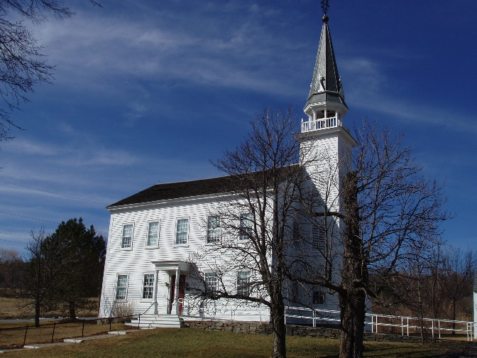flexible guide for growth rather than a rigid document. As changes occur and new conditions arise, revisions will be considered so that the Plan Update remains a sustaining and living document for Town officials and residents to reference.
In general, a comprehensive plan should be reviewed every 2-5 years (or as opportunities / issues arise) and should be updated every ten years. In addition, statistics in this document should be updated whenever new census data is released. A census is in process as of this review. This is the first update to the Plan adopted in 2006.

A Brief History of Duanesburg Christ Episcopal Church
Duanesburg derives its name from its founder and proprietor, the Hon. James Duane (1733-1797) of New York City, who was a respected jurist and influential New York delegate to both sessions of the Continental Congress. During the Revolution, Duane was devoted to the cause and applied himself tirelessly to its successful conclusion, playing an invaluable role in its financing. After the war, in 1784, Duane was appointed mayor of New York City. In 1788 he was elected a member of the Constitutional Convention, and under the new constitution was nominated by President Washington to become the first federal District Judge of the New York District, retiring in 1794.

In pre-colonial days, the rolling hills of present day Duanesburg served as hunting grounds for Native American groups including the Mohawk from settlements along the Mohawk River and the Schoharie Creek. European settlement and land speculation reached the area in the early part of the 18th century. In 1741, James Duane’s father, Anthony Duane, a New York City merchant, purchased 6000 acres of Albany county wilderness, which he later bequeathed to his four sons. Through inheritance and purchase, by 1764 James Duane had acquired a total of 20,000 acres in the wilderness west of Schenectady. On March 13, 1765, by action of the Governor and colonial Council, the Town of “Duanesburgh” was created with 42,000 acres included within its boundaries. Duane had the land surveyed and laid out in 100-acre farms called “great lots.”

Duane worked tirelessly to populate his town, vying with numerous competing 18th century land developers, most notable among whom was Sir William Johnson. In 1765 Duane was successful in attracting a group of German families from Philadelphia, and a few years later a large group of Scotsmen (hence, Scotch Ridge Road and the Duanesburg Presbyterian Church). Duane continued to acquire land, ultimately owning 36,000 acres in Duanesburg. By the time of his death in 1797, all the farm lots were occupied. For most of its first century, Duanesburg was a sleepy farming community. However, by the middle of the 19th century, the railroad made its way through the heart of the town. By 1907, the Village of Delanson had not only taken its name from the railroad responsible for its founding (Delaware and Hudson), but it hosted a major depot and boasted the largest coaling station in the world.

With US Route 20 (the Great Western Turnpike), the nation’s longest highway, cutting through the town, the automobile brought the world to Duanesburg’s door in the first half of the 20th century. Today, Duanesburg remains a characteristically rural community, but with the completion of I-88 in 1980 providing easy access to the greater Capital region, the town has become a bedroom community for the cities of Schenectady, Albany, and Troy.
The Town's present layout remains much the same as it was throughout the 19th century: vacant and occupied farmsteads with hamlets and villages at the major thoroughfares. Of the eight historic byways, five communities remain intact of significant historic concentrations of properties: The Village of Delanson, the larger hamlets of Quaker Street, Mariaville, and Duanesburg Four Corners, and the small hamlets of Eaton’s and Braman’s Corners. These settlements contain important and broad ranges of architectural styles, including pre-Federal, Federal, Greek Revival, Italianate, Queen Anne/Eastlake, and Colonial Revival designs. The Town contains numerous structures identified in the New York and National Registers of historic places, among them Christ Episcopal Church consecrated in 1793, the Quaker Street Meeting House built in 1807, the North Mansion built in 1791, and the Duane mansion built in 1812. There are 55 cemeteries and at least 15 natural sites of interest such as Christman Sanctuary, Sheldon and Undine Falls, Schoharie Creek Gorge, Featherstonaugh State Forest, and Sheep Dip on South Chucktanunda Creek.

DUANESBURG TODAY

Physical Characteristics
Duanesburg’s physical characteristics play a significant role in shaping the Town’s land use. Duanesburg is a rural community with a landscape dominated by farmland, forests, rural residences, and hamlets. Duanesburg is the largest town in Schenectady County at approximately 70 square miles or 45,000 acres. As in 2006, it continues to be the least densely populated town in the County.

Physiography, Geology and Soils
The Town lies at the northern edge of the Allegheny Plateau with most of its area located at an elevation of 1,000 feet or more above sea level. Topography is somewhat rolling and ranges from a low of approximately 600 feet along the Schoharie Creek to nearly 1,500 feet above sea level in the center of town just west of the Duanesburg Reservoir. According to the Soil Survey of Montgomery and Schenectady Counties, most soils found throughout the Town have severe and severe to moderate limitations to development due to seasonal wetness, slow permeability, slopes, and shallowness. Most soils in town range from good to fair for agricultural use based on soil capability classes I-VIII. Prime agricultural soils are limited and located predominantly along the Schoharie Creek.
Most soils found throughout the Town have severe to moderate limitations to development.

Water Resources
There are three lakes and two reservoirs in the Town. The largest lake, Mariaville, is approximately 201 acres, 1.5 miles long and is located partially within the adjoining Town of Princetown. The Mariaville Lake shoreline is almost completely developed with single family residences. All residences around the lake have been connected to public sewer facilities which have been established in Sewer District no. 2. This has likely improved water quality in the Lake. There are three large state regulated wetlands (RJ-2, RJ-3, RJ-5) associated with tributaries to the lake.

The second largest lake, Duane Lake, is approximately 116 acres and ¾ mile long. The Lake is part of state regulated wetland RJ-10 which encompasses the lake. The lake is considered a tributary to the Normanskill Creek. The shoreline is completely developed with single family residences. The water quality in the lake is impacted by the long-term development around the lake. Residences on the lake have individual wells or draw water directly from the lake and have individual septic systems. The Town with the assistance of the Duane Lake Association is in the process of evaluating whether there are any acceptable and economic alternatives to individual septic systems for property owners adjacent to and near the Lake.

Featherstonhaugh Lake is 39 acres in size and considered part of state wetland RJ-5. It is part of the 660-acre Featherstonhaugh State Forest and is largely undeveloped. A small number of homes are located along the south and east shorelines. There are no documented water quality concerns. The few residences on the lake have individual wells and septic systems.
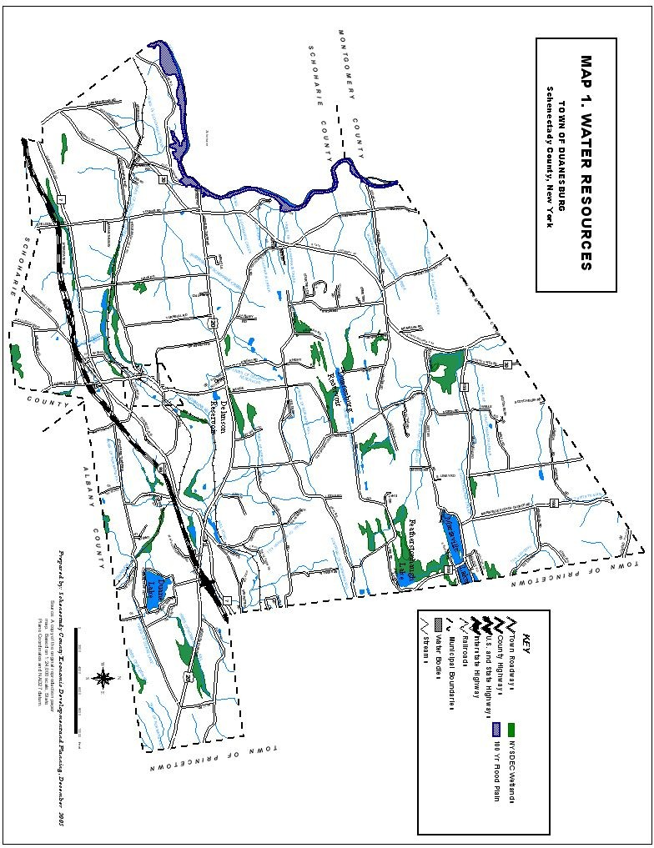

The Delanson Reservoir is located on an approximately 17-acre parcel owned by the Village of Delanson. The Reservoir is approximately 8 acres and holds around 26 million gallons of water (for further discussion on the Reservoirs see Utilities below). The Delanson Reservoir provides potable water to the Village of Delanson. There is a backup reservoir located in the Town of Duanesburg, outside Village limits, that is approximately 36 acres in size and ¾ mile long. However, the connection to this backup reservoir is in disrepair so the water held in this reservoir is no longer used. There is no development along the shores of either of the reservoirs.

The largest watercourse in the Town is the Schoharie Creek which forms the western boundary of the Town and flows north to the Mohawk River. The Normanskill Creek, South Chuctanunda Creek, Bowman Creek, Bozenkill and various sub-tributaries to the Schoharie Creek comprise the remaining significant watercourses. The Normanskill flows into the Watervliet Reservoir, a water supply for the City of Watervliet and the Town of Guilderland.

Waterbodies are classified by the NYS Department of Environmental Conservation according to their best and highest use including Classes A, B, C, C(t), and D. Class A, B, and C(t) waterbodies are considered “protected” and regulated by the Department of Environmental Conservation under Environmental Conservation Law, Article 15, Title 5 “Protection of Water.” Disturbance to the bed or banks of such streams requires a permit from the state.

There are over 30 wetlands in the town regulated by the NYS Department of Environmental Conservation (DEC) under Article 24, Title 7 “Freshwater Wetlands Regulations” as noted on Map 1. In general, any form of draining, excavation, or filling of a wetland, including the 100-foot adjacent area, is subject to regulation by the state. Although these wetlands are mapped by the DEC, it should be noted that these maps are general indicators of wetland locations. Wetland boundaries should be field verified prior to any land development activity occurring nearby.

Other streams and wetlands that are not regulated by the DEC are generally considered “waters of the United States” and under the jurisdiction of the federal government. The phrase “waters of the United States” includes navigable waters, but also includes non-navigable waterbodies, perennial and intermittent streams, and wetlands. Any disturbance to these waters is regulated by the U.S. Army Corps of Engineers. However, unlike state regulated wetlands, maps have not been prepared for wetlands under the sole jurisdiction of the federal government. The presence of these wetlands must be determined for each land development application.

Flora & Fauna
With European settlement, most of the Town was cleared for agricultural use. Remains of original forest lands were limited to marginal, more inaccessible areas. With a decline in agricultural uses in more recent times, many former farm fields are undergoing vegetative succession, the process by which nature reclaims the land and eventually returns it to a mature forest or other dominant vegetative community that existed prior to disturbance. As a result, approximately 50 percent of the town is currently forested to some degree. The increase in forest cover will probably continue, although it may be offset and fragmented to some extent by new residential and commercial development.

Forest lands are dominated by northern hardwoods, primarily beech-maple-oak forests. However, these forest communities differ from place to place depending on the stage of the forest community succession and microclimate. Common native tree species include several types of oak and birch, beech, maple, hickory, basswood, white pine, and hemlock. Some common shrubs and understory trees include hawthorn, shad, maple leaf viburnum, arrowwood, striped maple, and witch hazel. Reforestation efforts during the past 50 years created plantations of red pine, Norway spruce or Scotch pine in some areas of town. Many tree species such as the ash are currently being adversely affected by non-native invasive species such as the Emerald Ash Borer.

The variety of ecological communities and open spaces results in a healthy diversity of wildlife in Duanesburg. In addition to the many common mammals found throughout the region, the increasing forestation in town has facilitated the return of woodland mammals such as fisher, bobcat and black bears and possibly even moose. In the southwestern part of town (south of I-88) and in other areas of neighboring Schoharie and Albany Counties, the NYS Department of Environmental Conservation is permitting hunting of black bears because of increasing bear populations and expanding range.
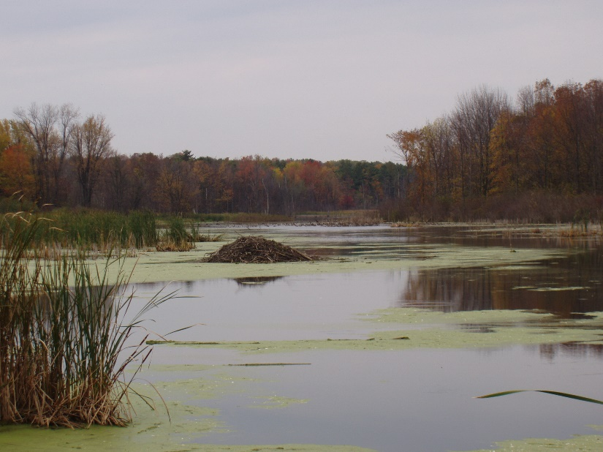
In addition to providing improved habitat for some species of large mammals, the increasing forested areas also provide improved habitat for breeding songbirds and other woodland bird species such as Wild Turkeys and Ruffed Grouse. These forests also support bird species such as Sharp-shinned Hawk, Cooper’s Hawk, Northern Goshawk, Red-shouldered Hawk, Wood Thrush and Canada Warbler. Eagles are commonly viewed now as they use Schoharie Creek and the other large waterways in the Town.

The many large wetland areas in town also support a wide variety of wildlife that may include at-risk bird species such as American Bittern, Least Bittern, and Northern Harrier. Wetland areas appear to be expanding due to increasing beaver populations and a decrease in agricultural activities.

Utilities
Most households in the Town are connected to an individual septic system and well. Given the difficult soil conditions in much of the town, there are several failing septic systems. Fortunately, the establishment of Sewer Districts 1, 2 and 3 have greatly improved this situation in most of the more densely settled areas of the Town such as the hamlet of Duanesburg which most recently was connected to public sewer.
Wetlands along Sheldon Road

The Duanesburg/Delanson Sewer District No. 1 began operation in 2002. Sewer District No. 1 provides sewage treatment at the Delanson Wastewater Treatment System which has been updated and improved over the years with the latest improvement project slated to commence in 2021. There are approximately 280 households serviced by the Sewer District No. 1. The Sewer District No. 1 serves the entire Village of Delanson and approximately 100 properties outside the Village along Cole and Duanesburg Roads in the Quaker Street Hamlet.

The Mariaville Lake Sewer District No. 2 was formed in 2001 and began operation in 2005. Sewer District No. 2 has its own wastewater treatment plant located in the Hamlet of Mariaville. There are approximately 290 households serviced by the Sewer District No. 2. The Sewer District No. 2 serves all properties along the shore of Mariaville Lake and some properties along Mariaville Road in the Mariaville Hamlet area and 45 properties in the Town of Princetown.

The Town’s newest sewer district, Sewer District No. 3 serves the Hamlet of Duanesburg and properties located on Rt. 7 to Cole Road. Sewer District No. 3 shares the Delanson Wastewater Treatment Plant with Sewer District No. 1. Sewer District No. 3 was formed in 2016 and commenced construction in 2018. Sewer District No. 2 has been operational since 2019, providing public sewer access for 122 homes and businesses.

There are no water districts in the Town of Duanesburg except for the Village of Delanson water supply. The Village of Delanson is served entirely by public water. Two surface water reservoirs, the Duanesburg Reservoir (not presently in use), and the Delanson Reservoir, both located north of the Village in the Town of Duanesburg provide the water supply. The Delanson Reservoir is located on an approximately 17-acre parcel owned by the Village of Delanson. The Reservoir is approximately 8 acres and holds around 26 million gallons of water. A slow sand filter water treatment plant with UV pre-treatment is located on site that can provide up to 88,000 gallons of chlorinated drinking water per day.

At one time, the Duanesburg Reservoir provided water to the Delanson Reservoir via a surface watercourse that feeds the “MacMillan Well.” From the well, water was transported 2 miles to the Delanson Reservoir via a 6-inch cast iron pipe. The connection between the reservoir is ‘said’ to be in disrepair. Therefore, only the Delanson reservoir is used to provide water to the village of Delanson. It is recommended funding be established to accurately, locate, assess and confirm the said “disrepair” if and when the town of Duanesburg and village of Delanson agree either co-op or transfer total responsibility of the reservoir to the town.
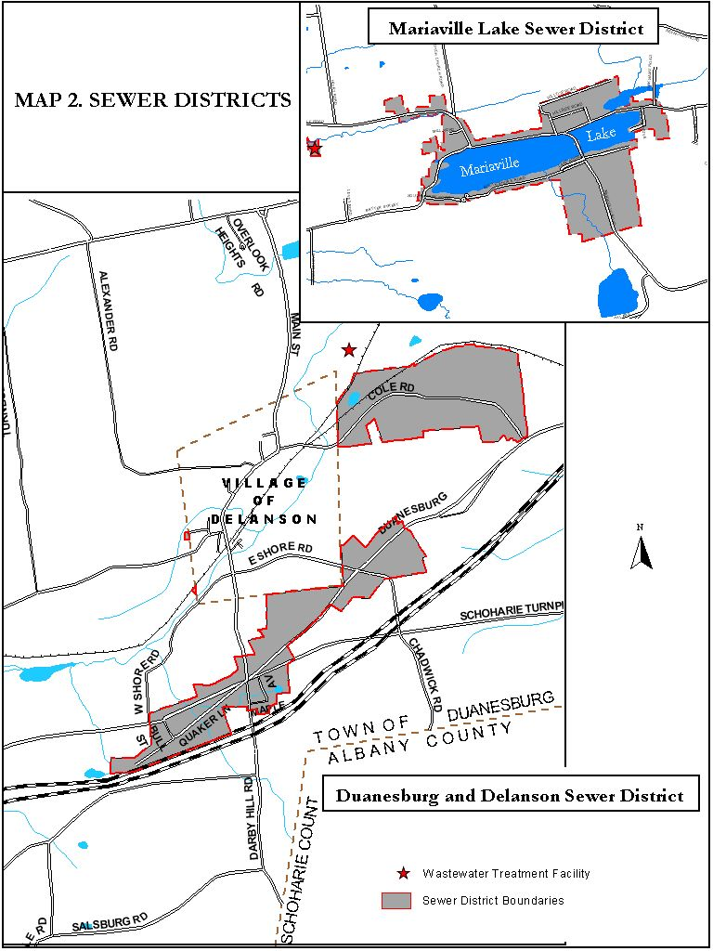
The watershed area of both reservoirs is approximately 1,700 acres. The Village of Delanson has watershed rules and regulations that were promulgated by the NYS Health Department in November 1973.

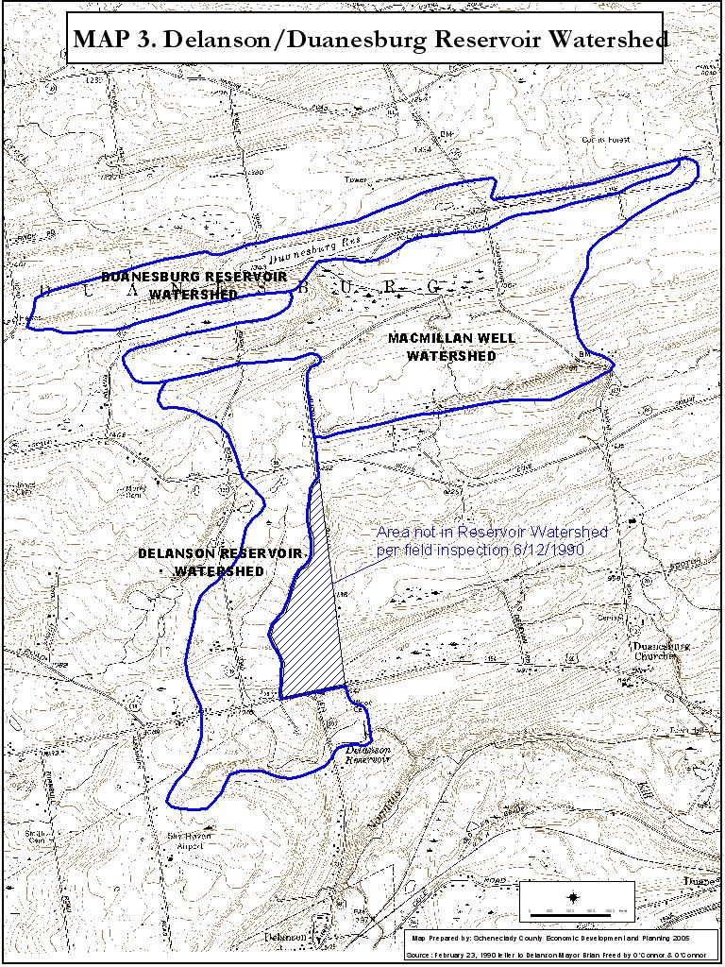

The Town no longer operates a sanitary landfill. The NYS Department of Environmental Conservation supervised the closing and capping of the former landfill located at Depot Road in 1992. The capped landfill is equipped with a leachate collection system maintained and operated by the Town. The leachate is collected and disposed of at the Wastewater Treatment facility for Sewer District no. 3 which is located on property owned by the Town in the Village of Delanson. Private solid waste haulers pick up both solid waste and recyclables in the Town under contracts with the residents and business and dispose of the solid waste and recyclables outside of the Town. Several businesses in the Town redeem bottles and cans subject to the NYS Bottle Deposit Law.

BROADBAND

The Duanesburg Broadband Committee was formed in early 2018 by a group of residents and elected officials of the Town of Duanesburg for the purpose of advocating for high speed broadband service to all residents, farms, and small businesses in town. With the pandemic of 2020 and the substantial numbers of Town residents working from home and all students being taught over the internet by the local school district, broad band access has become a necessity. Residences without such access are substantially less desirable in the marketplace. Surveys were distributed to all town residences (approximately 2000) and boots on the ground information was used to determine and map who was and who was not served with wired broadband. As of May 2018, five hundred ninety-eight (598) residences in town were not served.

Progress, as of February 14, 2020, toward serving town residences is as follows:

Provider | Locations served since Spring 2018 | Miles put in service since Spring 2018 | Broadband Service | Television Service | Telephone Service
Charter/Spectrum | 88 | 6.28 | X | X | X
Pattersonville Telephone | 27 | 2.50 | X | X | X
Verizon | 266 | 32.39 | X |  | X
Totals | 381 | 41.17

Duanesburg Broadband Committee mapping shows 217 locations in town currently remain unserved with broadband by any provider.

Maps are maintained and updated as service expansion progresses and can be found at the following web links:
Duanesburg Broadband Unserved Spring 2018 (with progress noted)
https://www.google.com/maps/d/viewer?mid=1zqpm9Z-VUvfk245UONYiwWO1j14kE-Ym&ll=42.79940386863833%2C-74.20113881523436&z=12

Duanesburg Broadband Unserved Spring 2020
https://www.google.com/maps/d/viewer?mid=1gut6mQN2PBdcakPHl6dixzfcUx2s1-wl&ll=42.782933564783164%2C-74.25165049506914&z=12

Key to Map Symbols
Blue Flag = Unserved location
Purple Flag = Verizon serves or expected to serve
Brown H Circle = Hughes Satellite grant in NY BPO Phase 3
Pink Wi-Fi Circle = Newly served by Charter/Spectrum
Yellow P Circle = Pattersonville Telephone
Orange Wireless Symbol = Hudson Valley Wireless

Transportation

Duanesburg’s transportation network is a tremendous asset with virtually no congestion or delays of any kind, and excellent Interstate Highway access with a direct connection to Interstate Highway (I-88) at exit 24. More than 14,000 vehicles travel the section of I-88 from Interstate I-90 at Interchange 25A to I-88 Interchange 24. Aside from the Interstate Highway, the main east-west routes are U.S. Route 20 and State Route 7, with State Route 30 running north-south through the west end of Town. Combined, these roadways provide a safe, well maintained network, allowing unimpeded mobility for all residents and travelers.

U.S. Route 20 is the busiest road in town. A Principal Rural Arterial, Route 20 has an Average Annual Daily Traffic (AADT) volume of nearly 11,000 between State Route 30 and the intersection with State Route 7. State Route 7 has an AADT of less than 5,000 between State Route 20 and State Route 30, which is also the border of Schoharie County. The principal north-south road is State Route 30. From the Schoharie County line to U.S. 20, State Route 30 has an AADT of 6000.Some very minor delays are experienced in the east bound a.m. peak hour approach to the Route 20 and Route 7 intersection in the hamlet of Duanesburg, as well as during the p.m. peak hour, westbound in this same location. The Town does not currently experience significant traffic congestion of any kind.

A “park and ride” lot is located on Route 20 about ¼ mile east of I-88 Exit 24. Bus service is provided to the City of Albany, Wolf Road, and the State Office Building Campus by Schoharie County Public Transportation.

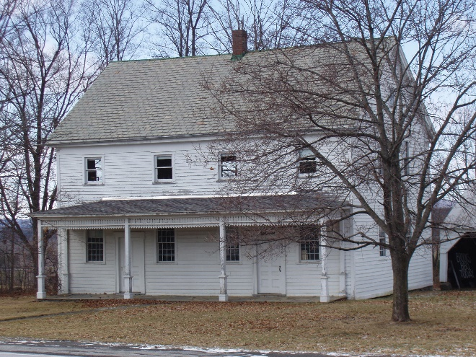Historic Resources
Four concentrations of largely intact significant historic properties remain in the Town including the Village of Delanson, the larger hamlets of Quaker Street and Mariaville and the small hamlet of Eatons Corners. The three hamlets and part of the Village of Delanson are designated as historic districts and listed on the State and National Registers of Historic Places. These areas contain important and broad ranges of architectural styles, including pre-Federal, Federal, Greek Revival, Italianate, Queen Anne/Eastlake, and Colonial Revival. In addition to the historic districts, the Town contains 29 structures on the State and National Register of Historic Places, 55 cemeteries and at least 15 natural sites of interest.
Quaker Meeting House
The historic Quaker Street Hamlet is located at the intersection of State Route 7 and State Route 395. About 40 homes in the hamlet were constructed in a severely plain style by Quaker Settlers during the early 1800’s. These homes, collectively, give the settlement a significant historic character. The Friends Meeting House is the hamlet’s most significant historic feature. This well -preserved wood frame structure, constructed in 1807, is an excellent example of the severely plain architectural style of the Quakers. The Friends Meeting House has been designated a National Historic Site by the U.S. Department of the Interior.
The Mariaville Historic District is located on the north side of Mariaville Lake at the intersection of Mariaville Road (State Rt. 159) and Batter Street. Approximately 10 structures are included in the district. The Eaton Corners Historic District is located at the intersection of Braman and Eaton Corners Roads in the northwestern part of town and includes approximately six structures.
The Town contains four historic districts and 29 structures on the National Register of Historic Places.
Duanesburg has an active group of citizens devoted to the study of the local history. After the Comprehensive Plan was adopted in 2006, the Duanesburg Historical Society purchased land and constructed a research and preservation facility in the hamlet of Quaker Street near to the Schenectady County Quaker Street Library both fronting on Duanesburg Road (NYS Route 7). The Duanesburg Historical Society has produced several books on local history that are available for purchase through their website. http://duanesburghistorical.com/

Police, Fire and Ambulance Services

Police protection is provided by the State Police and the County Sheriff. A sub-station of Troop G of the State Police is located on New York State Route 7 in the Town of Princetown. County Sheriff patrols are based out of downtown Schenectady.

There are six volunteer fire companies in the town of Duanesburg. The two largest districts, Mariaville and Duanesburg, provide service to approximately the eastern half of town. The remaining district includes Burtonsville, Delanson, Esperance, and Quaker Street volunteer fire departments.

The Duanesburg Volunteer Ambulance Corps provide emergency services. The Duanesburg Volunteer Ambulance Corps (DVAC) is housed on State Route 7 approximately one mile west of the Hamlet of Duanesburg. The DVAC provides coverage for the Town. DVAC and the Town have recently signed a new contract which will ensure full-time staffing during the day by paid EMTs to supplement the much-appreciated volunteers who are able to provide supplemental staffing during the day and to fully staff the facilities during the evening and night-time hours. The Village of Esperance Fire Department also provides ambulance and EMT services in the western section of town. The Town is served by the County 911 system and participates in the County wide meetings addressing emergency services throughout the County.
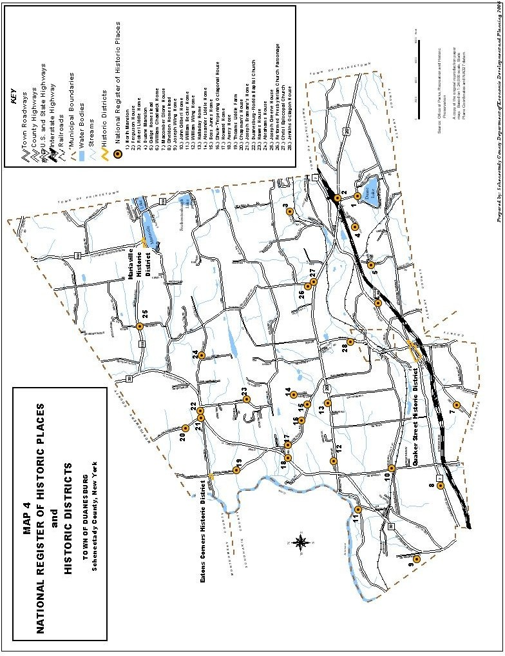

Public Parks and Recreation Facilities
Duanesburg has two Town Parks available for residents’ enjoyment - VanPatten Mill Park and the Robert B. Shafer Memorial Park. The 28 acre Van Patten Mill Park has basketball courts, a softball field and horseshoe pits. Swing sets and Jungle Gyms are available for the younger kids along with a pavilion for shelter. This park is also the site of the Summer Park Program sponsored by the Town of Duanesburg.
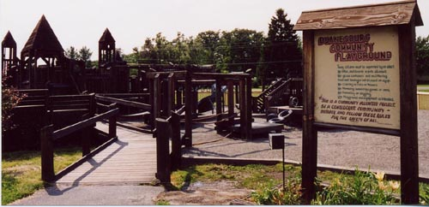The Robert B. Shafer Memorial Park is the newest park. It is located near the Duanesburg Elementary School and consists of 29 acres. The Park has three tennis courts, two basketball courts, a soccer field, a softball field, and a nature walk, along with a pavilion for shelter.
Across the street from the Shafer Memorial Park is the Community Playground located at the Duanesburg Elementary School. This wooden playground was constructed by volunteers and has fun activities for children of all ages.
A third park, a Veterans Memorial Park and monument, is located at the intersection of State Routes 20 and 7 and was dedicated in 2015.
The Duanesburg Little League owns a 23-acre parcel on New York State 20 where the Duanesburg Little League maintains at least five fields and buildings used for announcing the games, refreshments, and equipment storage.
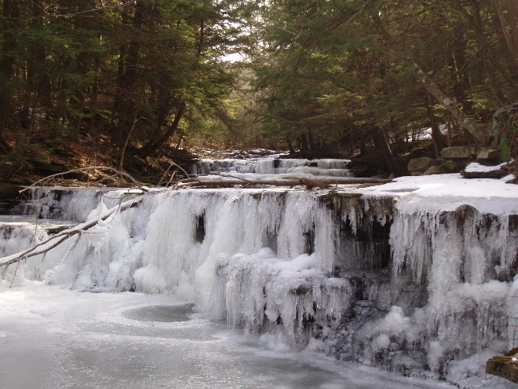Within the Town there is one County owned and maintained nature preserve (County Forest) and one state forest, the Featherstonaugh State Forest. The 105-acre County Forest is open year-round for hiking, cross country skiing, and snowshoeing. A small pond is available for fishing and hunting is allowed on a special seasonal basis. The 660-acre Featherstonaugh State Forest is open year-round. A dock provides canoe access to Featherstonaugh Lake for fishing.
The Christman Sanctuary is a 96-acre Nature Conservancy Preserve located along the Schoharie Turnpike. It is open year-round to hikers and cross-country skiers. The waterfalls and pools of the Bozenkill top the attractions. The Sanctuary was formerly part of the Christman Homestead, which is listed on the State and National Registers of Historic Places. Developed in 1888 by farmer/poet W. W. Christman, it was one of the first wildlife sanctuaries in the United States.
The Town owns a 90-acre parcel directly north of the County Forest Preserve. The parcel is forested with hiking trails.
Bozenkill is Dutch for Noisy Stream
The Duanesburg YMCA facility in the Village of Delanson was constructed after the adoption of the Comprehensive Plan in 2006 by the Duanesburg Area Community Center (DACC). The YMCA has aquatic facilities including an Olympic size pool and jacuzzi. The YMCA has a gym and numerous smaller rooms for classes in aerobics, spinning, yoga, dance, and general physical activity, as well as team sports. The workout room has a full complement of workout equipment including weight machines and treadmills. The YMCA has facilities for childcare and a community room. Many community activities take place at the YMCA and it is a welcome improvement in the quality of life for residents in the Town.
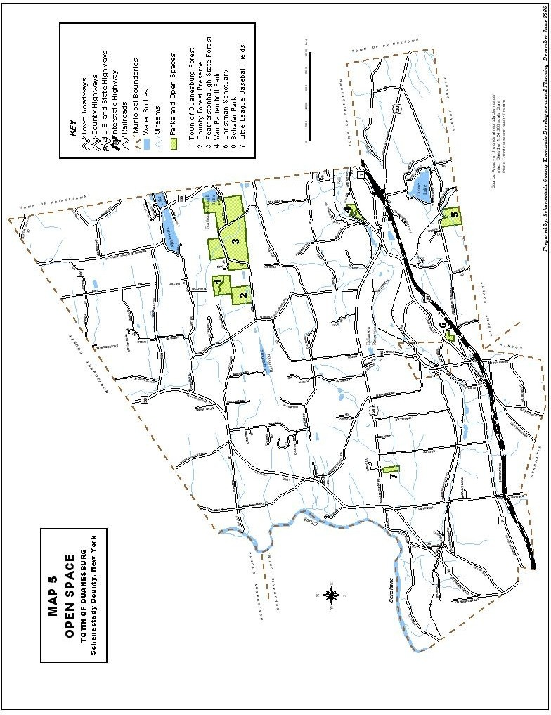

School District
Most of the town, including the Village of Delanson, is located within the Duanesburg Central School District. The Schalmont School District encompasses a large portion of the northeastern part of town. Two additional school districts, Amsterdam, and Schoharie encompass small areas of the town in the north and southwest respectively.
The Duanesburg Central School district has a 2019/2020 enrollment of 669 students in grades K-12. The district has two campuses--an elementary school housing students in a UPK program through grade 6 and a Junior-Senior High school building, housing students in grades 7 through 12. The district recently constructed state-of-the-art auditorium and outdoor track facilities. Plans are underway to move the 6th grade program to the upper campus to improve alignment with new curriculum programs. The 2020-2021 budget is $17,565,000. According to 2020 data, school taxes for district market value of $300,000 homes were $5,889. Neighboring schools for comparison, are Schalmont, ranked 25 ($6,358), and Schoharie, ranked 62 ($6,569)

In addition to traditional academic courses, students may participate in a number of unique programs: Through an arts-in-education grant, the district is able to provide students in all grade levels with access to a professional-level music, art and dance program with Proctors Theatre. Advanced-level classes offer students the opportunity to earn college credit while in high school through the Project Lead the Way program, Advanced Placement and University in the High School classes. Several courses provide students with more hands-on experiences in forensics, health, journalism, and environmental science. Access to career education opportunities are provided by the Capital Region BOCES Career & Technical School, offering students hands-on experiences.
Dozens of extracurricular clubs and activities available at the high school and elementary school, including Art Club, Drama Club, Musical Performance opportunities, Student Council, Yearbook, Lego and STEM-focused programs, and active and award-winning Masterminds team and Odyssey of the Mind program.
The Duanesburg Central School District offers students numerous opportunities to develop and recognize students’ talents in athletics. More than 10 different sports programs are available across three seasons, including cross-country, golf, soccer, football, swimming, bowling, basketball, volleyball, wrestling, cheerleading, softball, baseball, and track and field. The district is a member of the New York State Public High School Athletic Association, (NYSPHSAA) competing as a Class C and D school (depending on sport) in Section II. League affiliation is with the Western Athletic Conference. Duanesburg has been recognized as a District of Distinction by the New York State Public High School Athletic Association (NYSPHAA) for achieving Scholar-Athlete status for all varsity teams. Two former Duanesburg athletes qualified for the 2020 Olympics (Cycling and Wrestling).
Duanesburg Central School District offers students and their families in-house expanded behavioral health services through a partnership with Northern Rivers, an organization that includes the Northeast Parent & Child Society and Parsons Child & Family Center.
Duanesburg has been ranked among the top 20 school districts (18th - 2019/2020) in the Capital Region by the Albany Business Review and is ranked a top 100 school in New York State by Buffalo Business First, which examines the performance of more than 460 districts.

The district’s graduation rate consistently tops 90 percent.
View the video, “Small Schools, Big Impact,” about our Duanesburg Central Schools community.

Population Characteristics
Population projections provide public officials with a sense of the community’s future built environment—the man-made pattern of buildings and streets—and information on the future demand for community facilities, services, and housing. They also provide a frame of reference for administrative actions which have long-term effects. Decisions on capital facilities improvements such as water/sewer infrastructure, road maintenance needs, and parks and recreation facilities are in part based on population growth trends.

The population of the Town could be significantly changed by a number of factors, some of which are beyond the control of the Town’s government. Zoning changes, development decisions, major road improvements, water and sewer services, and employment changes caused by an exit or entry of major employers can have an impact on Duanesburg’s growth. These factors can have an impact whether they occur within the Town or in surrounding communities.

The two primary sources of information used to construct population estimates and projections are natural growth (the net difference between births and deaths) and migration. The following discussion attempts to estimate growth the Town may experience over the next 10-20 years. It is based on regional trends and current Town land use policies.

Population Changes and Projections

Regional Population Growth

From 1950 to 2000, the Capital District population increased from 589,359 persons to 794,293 persons, a net increase of 204,934 or 35 percent. During this same period, the fastest growing county of the region’s four counties was Saratoga, which grew from 74,869 persons in 1950 to 200,635 persons in 2000, a net increase of 125,766 persons or 168 percent. Since 1950, Saratoga County has accounted for 61 percent of the region’s population growth. During this 50-year period, Albany County’s population increased by 23 percent (55,179 persons); Rensselaer County’s by 15 percent (19,931 persons); and Schenectady County’s by 3 percent (4,058 persons).

More recently, growth in the region has been even more concentrated in Saratoga County, with nearly 90 percent of the region’s population growth between 1980 and 2000 occurring in Saratoga County. Over this 20 year period, Saratoga County’s population increased by 31 percent (46,876 persons); Albany County’s population increased by 3 percent (8,656 persons); Rensselaer County’s population increased by .4 percent (572 persons); and Schenectady County’s population decreased by 2.3 percent (3,391 loss).

During the last census period – 2000 to 2010 – the Capital District population increased by 5.5% to 837,967 (43,674 persons) and Schenectady County’s population increased by 5.58% to 154,727 (8,172 persons). Saratoga County’s population increased by 9.46% percent (18,972 persons), Albany County’s population increased by 3.27% (9,639 persons), and Rensselaer County’s population increased by 4.52% (6,891 persons). Population growth in the region continues to be much lower than the national rate where during this same census period, the U.S. population increased by 9.7 percent.

The CDRPC projects a net population gain for the Capital District of 6.8 percent (57,045 persons) and 33,333 households between 2010 and 2050. While the bulk of the growth will continue to occur in Saratoga County, the Town of Duanesburg’s population is projected to grow 12.25 percent from 6,122 in 2010 to 6,872 in 2050, or an average of approximately 19 persons per year. Overall, Schenectady County is projected to grow 3.88 percent (6,006 persons) from 154,727 in 2010 to 160,733 in 2050 with moderate growth in Niskayuna, Glenville, Princetown, Duanesburg and the western part of Rotterdam.

Town Population & Projections
Population growth in Duanesburg has followed the regional trend of a decline in population of the region’s cities, robust growth in the suburbs, and moderate to little growth in rural areas such as Duanesburg. Growth in the Town of Duanesburg has occurred largely because of factors external to the Town. Duanesburg remains a rural residential community with workers commuting to jobs in other communities and increasingly working from home at businesses located outside the Town or running businesses from home. As a result, growth trends in the Capital District will continue to have an important impact on the Town’s future. If the region’s population stagnates or declines, growth will be tempered in Duanesburg. The Town’s population projections provided below are based on a moderate regional growth scenario (.3 percent per year) as projected by the CDRPC.

From 1980 to 2000, Duanesburg’s population increased 23 percent (1,079 persons). From 2000 to 2010 Duanesburg’s population increased 5.41% (314 persons).

As shown in table 1, while the town’s population is projected to increase over the next 30 years, the rate of that growth is projected to steadily decrease.

Table 1. Town Population Change (1980-2040
Year | 1980 | 1990 | 2000 | 2010 | 2020 | 2030 | 2040 | 2050
Population | 4,729 | 5,474 | 5,808 | 6,122 | 6,451* | 6,714* | 6,863* | 6,872
% Change |  | 16% | 6% | 5.4% | 5%* | 4%* | 2%* | 0.13%
Source: U.S. Census Bureau
*Capital District Regional Planning Commission projection

School age population, which had grown slightly during the 20 year period from 1980 to 2000, has declined in the 20 year period since, even while the overall population continued to increase.

Table 2. Primary School Age Population (5-19 yrs)
Year | 1980 | 1990 | 2000 | 2010 | 2020
Population | 1,274 | 1,262 | 1,365 | 1,236 | 1,200*
% Change |  | (-1%) | 8% | (-9.5%) | (-2%)
Source: U.S. Census Bureau
*Capital District Regional Planning Commission projection

Besides regional economic development, the energy situation could also affect the Town’s growth. Since most residents commute greater than average distances to work by automobile, any significant change in commuting costs could affect residential development within Duanesburg. According to the 2000 Census 53 percent of town residents commute 30 minutes or more to work and over 80 percent drive 20 minutes or more. These commuting times are significantly higher than the County wide average where only 28 percent of residents commute 30 minutes or more and approximately 50 percent drive 20 minutes or more. During the Covid-19 pandemic that occurred in 2020, many more businesses accommodated employees working from home. If this trend continues living and working in rural areas such as Duanesburg may become more popular and accepted as a practice. Of course, this depends in large part on the availability of broadband that is needed for most employees to successfully work from home.

Table 3. Travel Time to Work (Percent of Residents) 2000
Municipality | 20 min. or more | 30 min. or more
Schenectady County | 51% | 28%
Duanesburg | 83% | 53%
Rotterdam | 51% | 26%
Source: U.S. Census Bureau

Mean travel time to work, workers age 16 years+ 2014-2019

Municipality | Minutes
Schenectady County | 22.8
Duanesburg | 30.9
Rotterdam | 23.3
Source: U.S. Census Bureau

Another issue that may temper population growth is the lack of services and housing opportunities for seniors. As shown in Table 4 the population 65 years and older comprises approximately 12.4 percent of the Town’s population compared to 14.9 percent Countywide. As the population ages in the coming years, senior citizens may not choose to reside in the town due to a lack of services or housing opportunities. The Hannaford grocery market on premises pharmacy has been a substantial benefit to the community that lacked a pharmacy for many years.
Table 4. Population Distribution by Age Group (2010)
Duanesburg Schenectady County
Under 5 years | 281 | 4.6% | 9,276 | 6%
5 to 14 years | 780 | 12.7% | 19,564 | 12.6%
15 to 24 years | 737 | 12% | 20,961 | 13.5%
25 to 34 years | 496 | 8.1% | 18,557 | 12%
35 to 44 years | 867 | 14.2% | 19,855 | 12.8%
45 to 54 years | 1,159 | 18.9% | 24,220 | 15.7%
55 to 64 years | 1,040 | 17% | 19,211 | 12.4%
65 to 74 years | 486 | 7.9% | 10,693 | 6.9%
75 years and over | 276 | 4.5% | 12,390 | 8%
Total | 6,122 |  | 154,727
Source: U.S. Census Bureau

Development Trends

Back in 2016 modest growth was projected for the Town, based on a belief that the high cost of real estate in the inner suburban towns and relative availability of land in the Town may create increased development pressure. The 2006 Comprehensive Plan also observed that development regulations implemented by Duanesburg and adjacent communities could also influence development patterns. The 2006 Comprehensive Plan also observed that if the regulatory environment is perceived as more burdensome in the inner suburban communities, development pressure may increase in Town. Likewise, the 2006 Comprehensive Plan stated that if the Town provides increased flexibility in the type of housing permitted or expands public sewer and/or water facilities, an increased rate of development may follow. Nonetheless the 2006 Comprehensive Plan identified limitations on such municipal infrastructure and concluded that development can probably be expected to remain at or under historic rates of approximately 30 units a year. Figure 1 below provides information on building permits issued between 2013 and 2019.

By way of historical comparison, between 1980 and 2005 the Town issued building permits for 788 housing units for an average of approximately 30 per year. Between 1986 to 1990 the Town averaged 43 units per year. From 2001 thru 2005, the Town averaged 37 units per year.

More recently the Town has experienced much slower growth in single-family homes and given these trends it appears unlikely that the Town’s Growth will outpace its existing resources. Over the past ten years, a number of property owners have applied to the Town Planning Board to merge approved subdivision lots which had previously been approved and which were proposed to be developed with single-family homes and new Town roadways and stormwater infrastructure. Rather than subdivisions created with new Town Roads and shared stormwater infrastructure, most subdivision requests that appear before the Town Planning Board involve lot line adjustment or the creation of one or two new lots as part of long term planning for future homes that may be occupied by family members. Very few major subdivisions have been proposed in the last ten years and the vast majority involve fewer than five lots. Almost all have frontage on existing Town roads.

Building Permits Issued for Single Family Residences
2013 | 2014 | 2015 | 2016 | 2017 | 2018 | 2019
23 | 9 | 9 | 17 | 14 | 13 | 17

Figure 1

The above table shows how many building permits were issued for single family homes from 2013 to 2019. The Town Building inspector provided the following statistics for issuance of demolition permits, permits for single family dwellings, two family dwellings and multifamily dwellings:

Year | Demolition | Single Family | Two Family | Multi Family
2011 | 3 | 17 | 0 | 0
2012 | 8 | 13 | 0 | 0
2013 | 6 | 23 | 0 | 0
2014 | 4 | 8 | 1 | 0
2015 | 12 | 9 | 0 | 0
2016 | 5 | 16 | 1 | 0
2017 | 7 | 14 | 1 | 1*
2018 | 11 | 15 | 2 | 0
2019 | 1 | 11 | 0 | 0

* (7) units former school building adaptively reused in Mariaville;

From 2011 to 2019, as shown in the table above, the Town has issued far less than the 30 residential units per year predicted in the 2006 Comprehensive Plan. In the past five years the Town has issued at most 16 building permits per year for single family homes. Given the modest growth and the nature of the lots which typically have frontage on existing Town roads, this appears to be the trend for growth in the Town. The vast majority of the “large” planned residential subdivisions are pre-2000. The 2006 Comprehensive Plan predictions concerning the establishment of larger subdivisions with new roadways and designated open space has not occurred. With the availability of public sewer in more areas throughout the Town, more development of businesses and residential lots may occur but recent trends in the issuance of single-family building permits are not showing an increase due to the availability of municipal sewers so far.

Housing/Household Characteristics

There are 2,533 housing units in the town, 85.6 percent of which are owner occupied, of the occupied homes 11 percent occupied by renters, and 8 percent vacant. Of the housing units, 2,092 or 91 percent are single family homes. Approximately 55 percent (90) of the reported vacant units are for seasonal or recreational use. Median household income in town is $86,729. This is 36 percent higher than Schenectady County’s ($63,785) and 25 percent higher than the Capital District’s median household income of $65,127. Such a relatively high median household income makes it difficult for the Town to qualify for many federal and state grant programs based on low/moderate income.

Of the 2,533 households in the Town, 197 (7.8 percent) had income in 2010 below the poverty level. Countywide, households with income below the poverty level is more than the town’s rate at 11.3 percent. However, excluding the City of Schenectady, the town’s household poverty rate is similar to the level Countywide, where 8 percent of households had income below the poverty level.
The median sales price for a house in Town in 2020 was $250,000.
According to the 2010 Census, the median value of owner-occupied single-family housing units was $213,000 in the Town and $165,400 for the entire County. Currently, the median sales price for houses in the Town and County is $250,000 and $169,700, respectively.

Land use
There are 3,307 parcels in the Town of Duanesburg totaling 43,750 approximately acres. The total equalized assessed value of all parcels in Town is $579,900,983 for 2020 (see Table 5). Over 81% of the assessed value in town comes from residential property. Commercial property accounts for just over 3.76% of the assessed value at $21,845,761 and Agricultural accounts for only 1.5% of the assessed value at $8,902,865. There are 58 tax exempt properties with a total value of $16,674,161, or just under 3% of assessed value. Residential property carries the bulk of the tax burden. Given that commercial property accounts for only 3.76% of the assessed value in town, a significant increase in commercial property would be required to have even a minimal impact on the taxes paid by residential property owners.
Table 5. Land Use (Numbers of Parcels and Assessed Value)

Agriculture / Forested Land | Parcels | 44
 | Value* | $10,295,818
Residential | Parcels | 2258
 | Value* | $475,267,100
Commercial | Parcels | 61
 | Value* | $21,845,761
Community / Public Service | Parcels | 80
 | Value* | $37,472,040
Industrial | Parcels | 4
 | Value* | $5,930,906
Vacant | Parcels | 860
 | Value* | $29,089,355
Total | Parcels | 3307
 | Value* | $579,900,980
*Equalized to 100/ Market Value
By land use category adopted by the Town Assessor, residential property accounts for 53% of the land acreage in town, followed by vacant property at 30% and agriculture/forest lands at 12%. Community/public service property accounts for 2.8% and commercial property comprises about 1% of all property. As a land cover, residential is exaggerated since in many cases large residential parcels are also utilized for agricultural/forest land purposes. Conversely, agricultural lands are underrepresented since many properties classified as residential or vacant for assessment purposes are some form of agricultural use. Approximately 10,500 acres, or 24% of the land acreage in town is located within the Schenectady County Agricultural District (see Map 6).
Village of Delanson
There are 179 parcels within the Village of Delanson totaling approximately 392 acres. The total equalized assessed value of all parcels in the Village is $33,537,134 for 2020 (see Table 6). Over53% of the assessed value in Delanson comes from residential property. Commercial property accounts for just over 2.6% of the assessed value and Agricultural / Forested Land accounts for only 0.02% of the assessed value.
Table 6 Village Land Use (Number of Parcels and Assessed Value)

Agriculture / Forested Land | Parcels | 1
 | Value* | $5,034
Residential | Parcels | 122
 | Value* | $17,931,208
Commercial | Parcels | 5
 | Value* | $875,169
Community / Public Service | Parcels | 14
 | Value* | $13,507,603
Industrial | Parcels | 1
 | Value* | $654,362
Vacant | Parcels | 36
 | Value* | $563,758
Total | Parcels | 179
 | Value* | $33,537,134
*Equalized to 100/ Market Value

Natural & Manmade Hazards
Review of existing natural and manmade conditions is a key element in the process of making land use decisions. Floods, landslides, hazardous material spills or dam failures are only "disasters" when people and property are affected. One important way to minimize our risk from natural or manmade hazards is to plan and develop our communities with those hazards in mind.

Minimizing risk is an essential focus of public safety planning. Every land use or public facility action taken by local government should be based on a recognition that some natural and manmade risk exists. The level of risk involved then becomes critical in determining when government involvement becomes necessary or desirable. The challenge is to balance the probability of potential hazard impacts with the characteristics of proposed land uses.

Natural Hazards
Within the Town the primary natural hazard is the floodplains of the Schoharie Creek and Normanskill. Secondarily, there are steep slope areas where soil stability can pose a potential landslide concern and overall steep grades can present vehicle access difficulties.

Manmade Hazards
Manmade hazards include dam failure (Gilboa and Mariaville Lake), and hazardous material spills/explosions associated with I-88, Canadian Pacific Railroad, natural gas pipelines, and some fixed sites such as fireworks manufacturing facilities.

Although the probability of an accident involving dam failure or hazardous materials within the Town is rather low it should not be ignored. Within the Town the presence of the above listed transport and fixed sites warrants the Town’s consideration in development of land use plans and review of developments that are located within the area vulnerable to a hazard incident. A map depicting the areas of vulnerability for manmade and natural hazards is contained in Appendix D.

Agriculture

The agricultural data represented in this update are the most current set of statistics representing Agricultural District no. 1, provided by the Schenectady County Planning Office at the time of finalizing this update.

The Town of Duanesburg is a rural community with traditional rural hamlets that serve as centers of residential and commercial development. There is limited public sewer and water service available within the Town. While the Town is separated into five zoning districts, the Agricultural-Residential (A-R) Zoning District comprises most of the Town. As stated in the Town's Comprehensive Plan, "The Town of Duanesburg encourages the preservation and protection of the economic health of the agricultural community and the prime and important agricultural soils." The town adopted a right to farm law in 1991.

A total of 10,334 acres or approximately 22 percent of the Town of Duanesburg is proposed for inclusion in Agricultural District No. 1. This is a small decrease of 301 acres since the 2012 eight-year review.

The proposed district lies predominantly in the Town's Agricultural & Residential (R-2) zoning district. Principally permitted uses in the R-2 District include customary agricultural uses and roadside stands for the sale of products grown on-premises.

Recent non-farm development in and adjacent to the proposed agricultural district appears to be limited to large lot residential subdivision activity. A total of 42 parcels (702 acres) are proposed for removal from the district as a result of this review.

Overall Status of farming and farm resources

Agricultural District No. 1 Profile (2020)
The proposed Schenectady County Agricultural District No. 1 consists of 18,898 acres comprised of 329 tax parcels, or approximately 14 percent of the County land area (see Map 1). This is a decrease of 858 acres, or approximately 4 percent, from the district's current 19,756 acres and an increase in 134 acres since the last eight-year review in 2012.
Table 2. Agricultural District Acres by Town (2012 – 2020)
Town | 2012 District Acres | 2020 District Acres | Change in Acres | Percent Change
Duanesburg | 10,635 | 10,334 | (-301) | (-3 %)
Glenville | 2,646 | 2,759 | 113 | 4 %
Niskayuna | 141 | 124 | (-17) | (-12 %)
Princetown | 3,195 | 3,291 | 96 | 3 %
Rotterdam | 2,148 | 2,389 | 241 | 11 %
TOTAL | 18,765 | 18,898 | 134 | <1 %
Source: Schenectady County Department of Economic Development and Planning

As discussed further below, 70 tax parcels comprising 1,138 acres, or approximately 6 percent of the 2019 district, is proposed for removal from the district due to residential subdivisions, commercial development, lack of any agricultural activity or at the request of the landowner.

Most of the proposed district (55 percent) is located within the Town of Duanesburg. Seventeen percent of the district is in Princetown, 15 percent in Glenville, 13 percent in Rotterdam and less than 1 percent in Niskayuna.

According to landowner responses and staff review, a total of 144 farms (212 farm parcels) totaling 11,975 acres are identified in the proposed Agricultural District. Another 4,806 acres are identified as rented by farmers for a total of 16,781 acres of land in farms.

The largest land use category in the district is “Rural Residential with Acreage” (240) which comprises 43 percent of the district at 8,027 acres. Of the 110 owners (111 parcels), 86 responded to the survey (77 percent) and 69 are identified as farmers. Of the 41 non-farmers, 18 responded that they rent land to a farmer totaling 1,027 acres. A total of 6,579 acres (82 percent) of the lands categorized as 240 are identified as farms or have at least some portion of the land in farms.

Table 4. Proposed Agricultural District Land Categorization
Town | Proposed Ag. District Acreage | Land Categorized as Agriculture (100)¹ |  | Land Categorized as Rural Residential/Vacant (300)¹ |  | Land Categorized as Rural Residential (240)¹
 |  | Acres | Percent | Acres | Percent | Acre | Percent
Duanesburg | 10,334 | 3,569 | 35% | 2,153 | 21% | 4,114 | 40%
Glenville | 2,759 | 663 | 24% | 905 | 33% | 1,155 | 42%
Niskayuna | 124 | 0 | 0% | 37 | 30% | 56 | 45%
Princetown | 3,291 | 405 | 12% | 949 | 29% | 1,454 | 44%
Rotterdam | 2,389 | 0 | 0% | 710 | 30% | 1,249 | 52%
TOTAL | 18,898 | 4,637 | 25% | 4,754 | 25% | 8,027 | 43%
¹Source: NYS Division of Equalization & Assessment. Refers to the property class assigned by the local tax assessor.

Landowner Applications (2019)
Landowners now have an annual opportunity to enroll property in the Agricultural District and the need to publicize the eight-year review is no longer as critical for property owners wishing to enroll property in the district. Nine additional parcels comprising 308 acres were submitted by 7 landowners for inclusion in the district during this annual review. Table 4 below identifies any proposed new applications received under this 8-year review.
Table 5. New Applications by Municipality
Municipality | No. of Parcels | Acreage | Percent of Total  New Acreage
Duanesburg | 6 | 130 | 42%
Glenville | 1 | 6 | 2%
Princetown | 2 | 172 | 56%
TOTAL | 9 | 308
Source: Schenectady County Department of Economic Development and Planning

Properties Proposed for Removal
A total of 70 parcels (1,138 acres) are proposed for removal from the 2019 district. The decision to remove properties is generally based on residential subdivision activity, commercial development, or at the request of the landowner.

If a landowner within the district failed to respond to the Agricultural District Review Sheet request, staff attempted to discern whether the property was still in agricultural use. If the property was determined to be in agricultural use, there are not any plans or proposals to develop the land, and local zoning is consistent with agricultural uses, the property was generally left in the proposed district. A total of 83 parcels consisting of 4,376 acres or 23 percent of the proposed district was left in the district despite receiving no response by the landowner to the survey request.
Table 6. Parcels Proposed for Removal by Municipality
Municipality | No. of Parcels | Acreage | Percent of Total Acreage Removed
Duanesburg | 42 | 702 | 62%
Glenville | 15 | 163 | 14%
Niskayuna | 1 | 16 | 1%
Princetown | 9 | 199 | 18%
Rotterdam | 3 | 57 | 5%
TOTAL | 70 | 1,138
Source: Schenectady County Department of Economic Development and Planning

VIABILITY OF FARMING WITHIN THE DISTRICT

The Nature and Status of Farming and Farm Resources

The total acreage of Agricultural District No. 1 as currently proposed is 18,898 acres and represents a small increase of 134 acres or less than 1 percent since the last 8-year review in 2012. The number of farms in the district stands at 144, an increase of 39 since 2012 and the number of acres in farms increased 32 percent from 12,711 acres to 16,781 acres. These increases are probably more attributable to variation in the interpretation of the data and the revised worksheet used to obtain data than an actual increase in farming activity in the County. In fact, since 2012 properties with a Real Property land categorization of “Agriculture” have decreased 1,336 acres (22 percent) within the district and now comprise 25 percent of the district compared to 33 percent in 2012.
Table 7. Real Property Land Classification as Agriculture (100s)
 | 2012 DISTRICT | 2020 DISTRICT | CHANGE
TOWN | ACRES (100s) | ACRES (100s) | ACRES | PERCENT
Duanesburg | 4,536 | 3,569 | (-967) | (-21 %)
Glenville | 620 | 663 | +43 | 0%
Niskayuna | 0 | 0 | 0 | 0%
Princetown | 742 | 405 | (-337) | (-45 %)
Rotterdam | 75 | 0 | (-75) | (-100 %)
TOTAL | 5,973 | 4,637 | (-1,336) | (-22 %)
Source: NYS Division of Equalization & Assessment. Refers to the property class assigned by the local tax assessor.

Dairy farmers tend to be full-time operators with all but one respondent to the County survey indicating they devote 100 percent of their work time to the farm operation. In fact, all respondents that reported dairy as their principal farm enterprise responded that they are a full-time farm operator. Dairy operations are also the most land consumptive agricultural use in the County. They require extensive cropland and support land. The dairy sector also supports a significant amount of other businesses (feed supplies and services, veterinarian services, milking and animal housing equipment supplies and services, milk haulers and shippers, and milk processors) and has a high economic multiplier effect.

It is a generally accepted tenet that farmland pays more in taxes than it costs a municipality in services. This is not true for every type of land use and depending upon the type of development that occurs on converted farmland, the costs of providing services to the new land use can be far greater than the revenues received by a community. Studies of towns in New York found that, on average, only 29 cents of every tax dollar generated by farm property was needed to provide services to the farm—producing a surplus of 71 cents. The 71-cent surplus puts farm property on par with commercial and industrial property as a tax positive land use. In comparison, most studies show that residences require $1.27 in services for every dollar they generate—producing a deficit of 27 cents. This is largely due to the cost of educating children that reside in the home.

Aside from the many positive aspects of farmland, farming and farmland should be valued based also on what it does not cost a community. As a net tax gain, farmland protection can be viewed as a strategy to maintain the long-term fiscal health of a community. To help support local agriculture, the Town adopted a right to farm law in 1995. The right-to-farm law is aimed at maintaining a supportive operating environment for farmers by limiting farmer/non-farmer neighbor conflicts. It supplements the New York State Agricultural District Law and the protections provided to farmers located within the Agricultural District. More recently the Town Board has adopted a local law encouraging Agri-tourism and wineries, meaderies, and breweries. The Town values its agricultural operations and intends to encourage agricultural endeavors which are consistent with the rural nature of the Town.

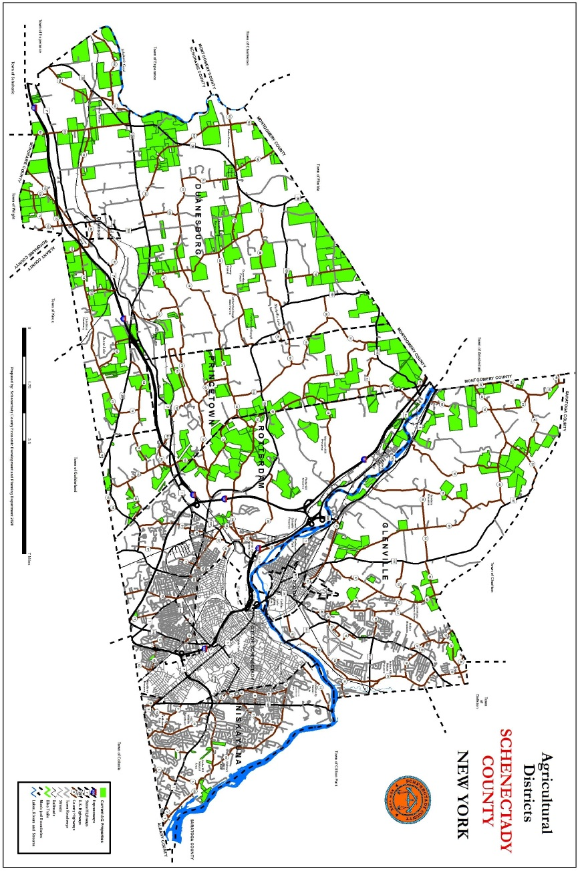
Economic Development
The Town of Duanesburg relies on the County and Metroplex Development Authority for much of its economic development efforts. The Metroplex administers the County’s IDA program which serves as the Town’s IDA.

There are no Empire Zones located within the Town; however, portions of the Town are within the Schenectady Metroplex Development Authority service area. Specifically, the Metroplex Development Authority service area extends into town along State Route 7 and U.S. Route 20 forming 7,000-foot-wide corridors along both highways. The Metroplex corridor encompasses the Town’s Commercial and Hamlet zoning districts except for Braman Corners and Mariaville Lake Hamlet areas.

The mission of the Schenectady Metroplex Development Authority is to enhance the long-term economic vitality and quality of life in Schenectady County by cooperative, purposeful actions and investments within the Metroplex corridor with particular emphasis on downtown Schenectady (www.schenectadymetroplex.org). Metroplex can design, plan, finance, site, construct, administer, operate, manage and maintain facilities within its service district. Metroplex project aid comes in several forms — loans and grants that are the traditional tools of economic development agencies and also with technical assistance or by connecting people with resources and information. The Metroplex does not supersede local authority and all applicable Town zoning and development regulations must be followed.

Metroplex’s activities are supported by a portion of county sales tax receipts. and the issuance of bonds. A portion (30 percent) of the sales tax money dedicated to the support of Metroplex is returned annually to the Towns within the County through the “Schenectady County Economic Development Tax Abatement Fund.” Metroplex has also awarded the Town grants for specific purposes such as the construction of sewers along NYS Route 7 to encourage commercial development as part of the newest sewer district in the Town, Sewer District No. 3.

Town Budget

The Town Budget information is posted on the Town website for each year. The Town receipts, expenditures and borrowing can be found in the Town’s annual report, which is posted on the Town of Duanesburg website https://www.duanesburg.net/ , and submitted to the Office of the State Comptroller.

Household Survey Results

The Town mailed a survey to all households in Town as part of the public outreach effort for this Plan Update. A copy of the survey and the tabulated results are included in Appendix A. The survey had a high response rate and the results of the survey along with comments received at public meetings provide insight into Duanesburg’s land development issues and helps direct the recommendations contained in this Plan Update.

GOALS, OBJECTIVES & RECOMMENDATIONS

Land Use

Goal: To preserve the rural character of the Town by promoting a land use policy that strengthens existing hamlet centers, protects important natural resources, maintains an efficient transportation network, provides for economical services and facilities, and fosters an orderly pattern of growth and development.

Hamlets Objective: Maintain and strengthen the traditional development pattern of the rural hamlet centers.

The Hamlets of Quaker Street, Duanesburg, and Mariaville serve as residential and commercial centers. Within the hamlet centers, the Town recommends:

adoption and enforcement of land use regulations that are designed to preserve the community’s historic character

development of housing densities based on the availability of public sewers and the capacity of the soils to handle on-site waste disposal

development of small commercial uses which are designed to serve local needs.

SEQRA Objective: Clearly incorporate the State Environmental Quality Review Act (SEQRA) procedure into the review process of the responsible board (i.e. Town, Zoning, and Planning Boards).

SEQRA is a state-mandated process for protecting residents of New York from development that would cause public harm if environmental, economic, and safety issues were not adequately considered. It establishes a process that requires the consideration of environmental factors early in the planning stages of the actions that are directly undertaken, funded, or approved by local, regional, and state agencies.

Establish a systematic approach to environmental review so that projects can be modified in the early planning stages to avoid unnecessary delays and minimize adverse impacts on the environment.

Amend Town zoning and subdivision laws to adequately reference SEQR requirements.

Agriculture Objective: Help preserve and protect the economic health of the agricultural community and the prime and important agricultural soils.

Consider allowing more flexibility in subdivision design to permit limited development of farmlands while retaining the most productive soils and agricultural areas.

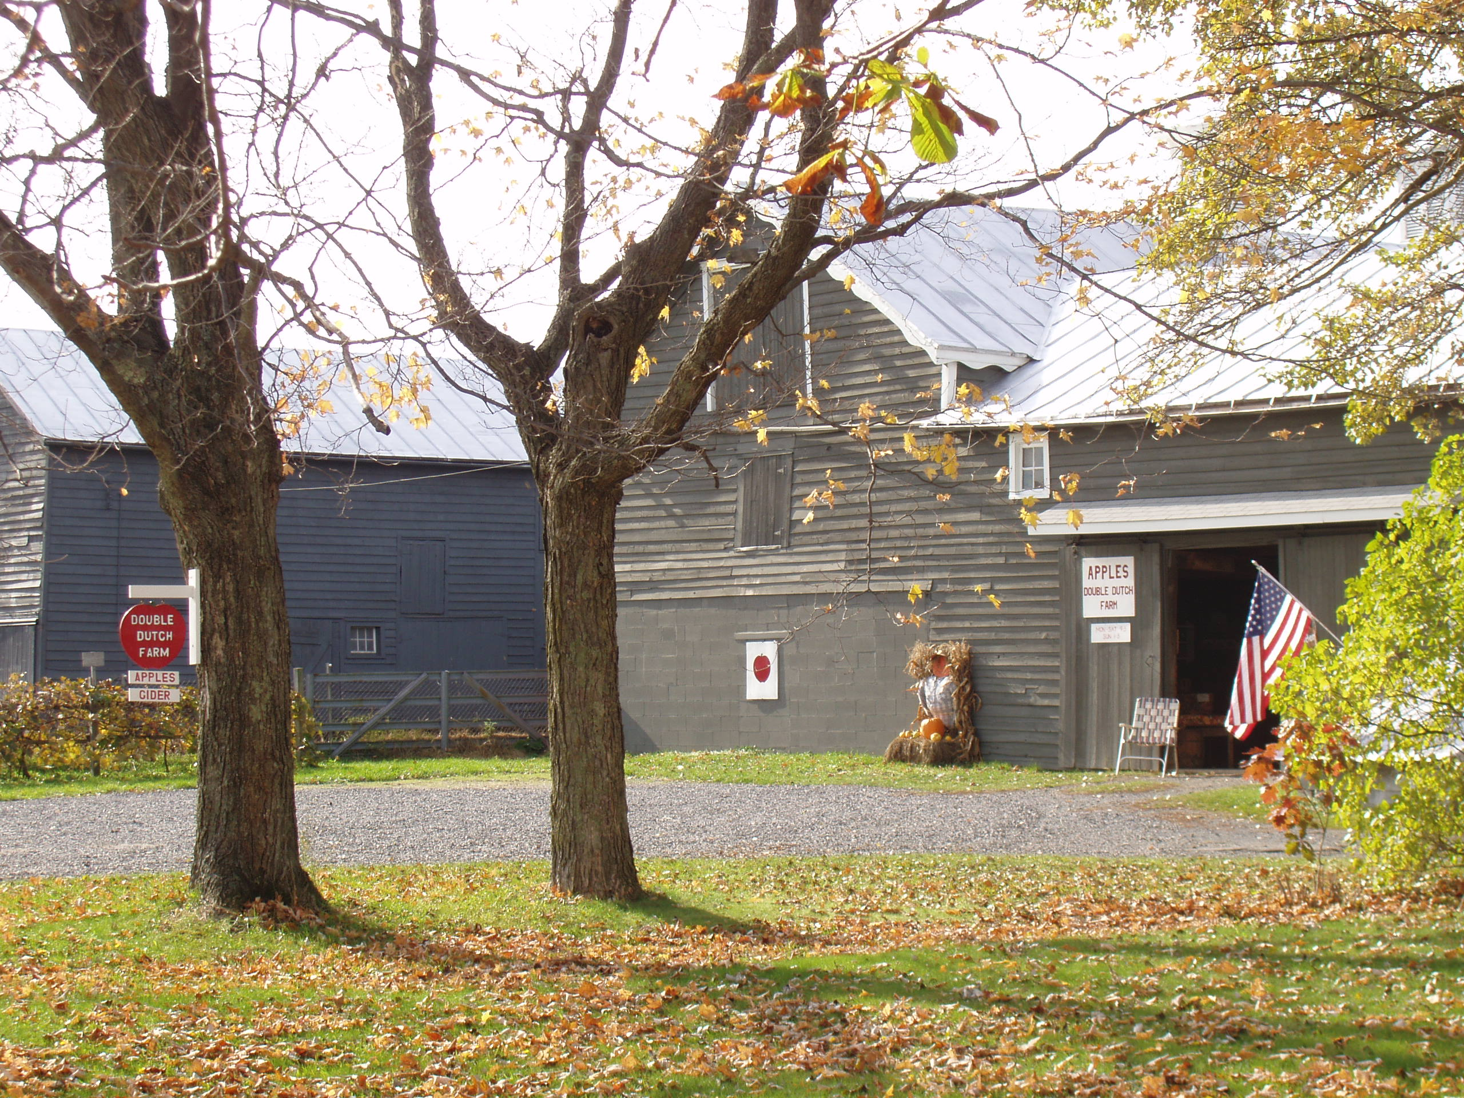Encourage enrollment of active farmlands into the County Agricultural District.

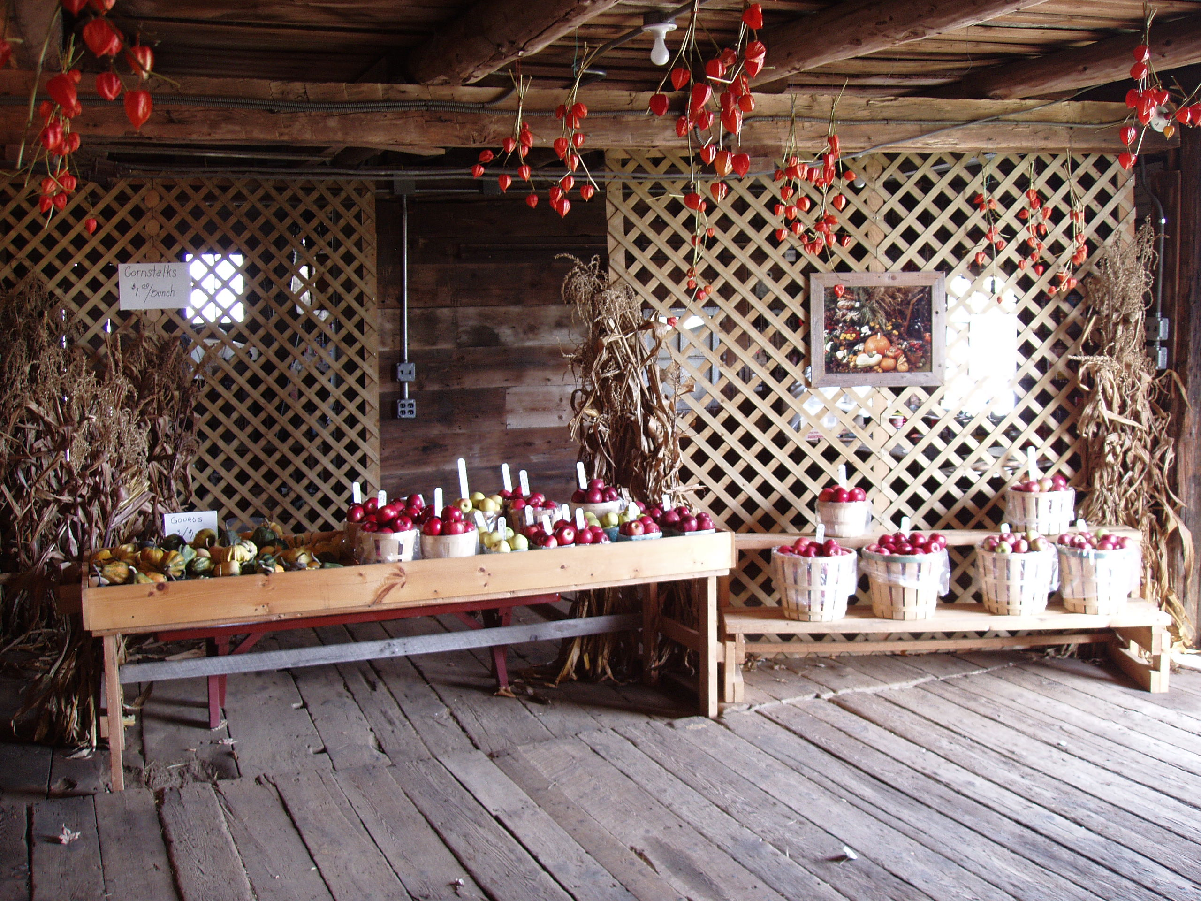Zoning laws should allow farm businesses to grow and allow small retail and/or Agri-tourism facilities as accessory uses to the farm. Farm support businesses should be allowed as of right in the Rural Residential/Agricultural District. Consideration should be given to allowing small, country livestock processing facilities. The current zoning law prohibits slaughterhouses.

Agriculture or farming should be broadly enough defined in the Town’s zoning law to include other accessory activities that are necessary to the success of the modern farm. The extent to which accessory uses are permitted is extremely important to the continuation of agriculture. Farm stands, sawmills, farm equipment repair, and agri-tainment activities are often an important part of farm income.
Small on-Farm Farm Retail Business

Ensure through the Town subdivision process that prospective neighbors to agricultural property/farm operations are given sufficient notice that they are purchasing lands near a farm and that farm activities occur that may cause noise, dust and odors.

Consideration should be given to providing buffers within the residential development from adjoining agricultural uses.

Commercial and Residential Development Objective: Adequately consider access management when locating commercial and residential development along state, county, and local roads.

Frequently local governments are pressured to locate commercial developments in strips along major transportation routes. Locating commercial uses in this manner along transportation corridors increases the number of access points (driveways and intersections), decreases the level of service of the road, and creates a conflict between local and through traffic. A related problem is the establishment of residential strips in rural areas. As with commercial strips, the establishment of residential lots with individual driveways contributes to the conflict between local and through traffic, decreases the level of service along the road, and inhibits the development of land which does not have direct access to a major roadway. The capacity of roads used for through traffic can be maintained by:

Creating deeper roadside zones to encourage centers of development and discourage strips.

Encouraging commercial use and residential developments to share a common access where appropriate.

Encouraging development within or adjacent to existing hamlet centers.

Planning for the construction of service roads between commercial uses.

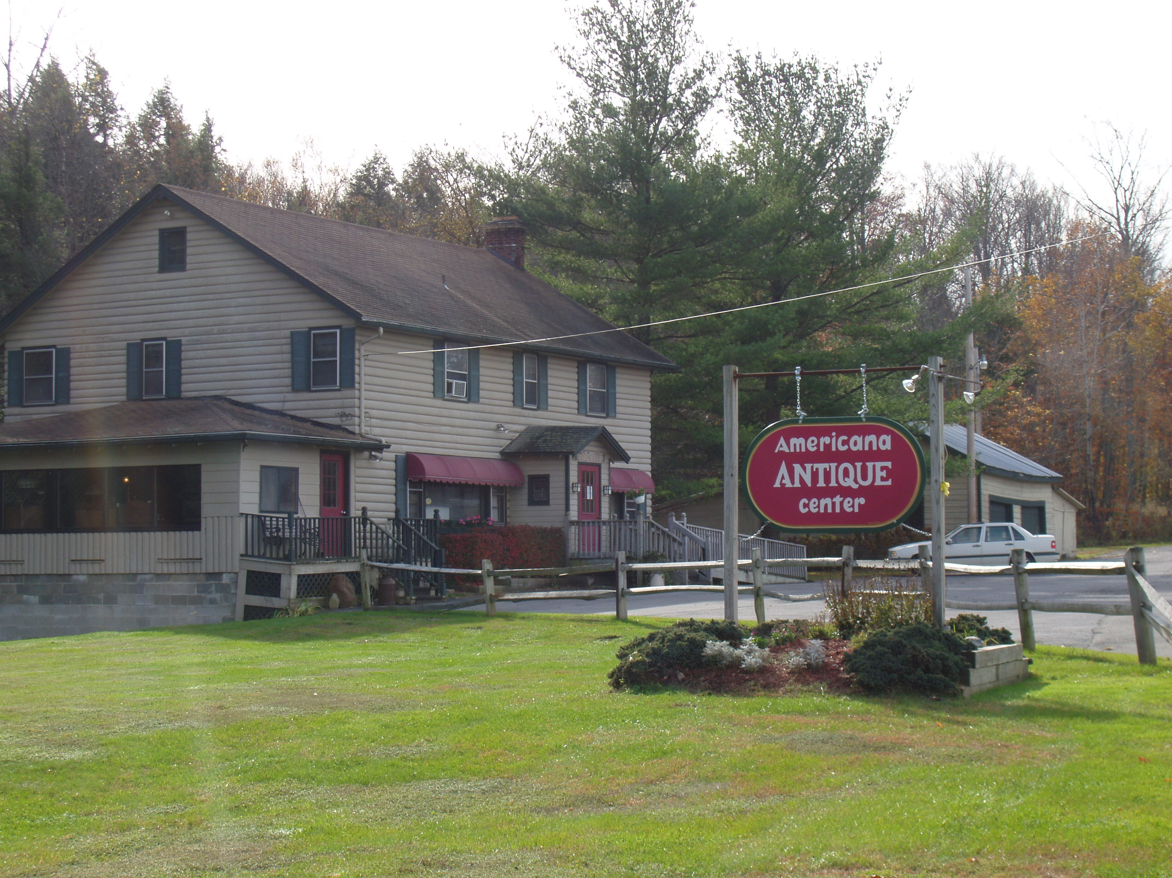

Low Impact Development (LID) Objective: Continue to allow low impact commercial developments such as antique/craft shops and small professional offices in the Rural Residential Agricultural District.

Commercial uses in the rural residential/agricultural areas should be designed and located with an informed respect for neighboring land uses and site limitations.

Continue to require a special use permit for such uses, to ensure that appropriate local review can take place to limit any potential negative impacts.

Housing

Goal: Provide a variety of quality housing alternatives which will meet the needs of Town residents and ensure that housing is properly located.

Housing Options Objective: Encourage and permit, with proper infrastructure, a variety of housing options (types) to meet the needs of all residents, especially young families and senior citizens.

Alternative types of housing should be allowed by special use permit to ensure a detailed project review takes place to limit any potential adverse effects on the existing neighborhood.

Mixed use housing (commercial on the first floor with residential use on the second floor) should be encouraged in the hamlet areas where there is adequate water and wastewater management.

Senior housing should be encouraged in the High Density Residential (R-1) and Hamlet (H) zoning districts where public sewer is available.

Housing Rehabilitation Objective: Encourage the rehabilitation of substandard housing.

Strictly enforce housing and sanitary codes to facilitate the rehabilitation of substandard housing.

Ensure that Town residents are aware of the HEAP and Weatherization Programs that provide financial assistance to make housing improvements and assist with heating bills to income eligible homeowners.

Affordable Housing Objective: Develop and implement plans to meet affordable housing needs of residents.

Continue to allow accessory in-law units in single family dwellings with a special use permit.

Continue to allow the creation of mobile home parks that meet strict design criteria.

Commerce and Industry

Goal: Preserve and strengthen the Town’s local employment opportunities and services and expand commercial property tax base.

Growth Objective: Encourage the growth of service, retail, and small industrial businesses which are compatible with existing land uses.

Adopt land use regulations that permit a wide variety of uses if they meet established performance standards that ensure compatibility with the surrounding area. Performance standards regulate the impact of uses (i.e., noise, odor, vibrations, lighting etc.) rather than the uses themselves. They should be readily measurable and enforceable.

Continue to support home-based businesses (home occupations) that are compatible with surrounding land uses. Regulations for home occupations should establish clear standards.

Ensure that commercial/light industrial developments proposed within the Metroplex Service Area are aware of the potential financial assistance available from the Metroplex Development Authority.

Encourage County IDA to fund agricultural economic development enterprises.
- Advocate for and enforce a Duanesburg ‘night skies’ initiative to sustain Duanesburg’s state and nationally known night skies (star gazing) value. Enforcement should include limitations to downcast lighting and limits to the brightness of signs. Consider changes to the Zoning Ordinance to define the regulations.
- The town supports the growth of agritourism business development and expansions that follow local law and Section 305 Ag & Markets law

Redevelopment and Expansion Objective: Encourage redevelopment of the hamlet areas and expansion of local service and retail uses.

Consider modifying the Town’s Zoning Law to specifically allow senior housing in the High Density Residential (R-1) and Hamlet (H) Districts where there is access to public sewer.

Consider modifying the town’s zoning law to include a new ‘C3’ zone for specific and limited areas of the town to locate and develop ‘last mile’ warehousing type opportunities that neighboring towns continue to take advantage of and Duanesburg continues to lose out on. The best location for a ‘C3” zoning district has been identified on or parallel to the routes 7 / I-88 corridor. Recommend a maximum 700,000 sq. ft. building to be allowable and 100 acres for development. Trucks could enter or exit the Interstate directly without traveling through town and impacting local roads

Address the decline of retail space needs and the increase of other types of non-disruptive businesses that support commercial growth and maintain rural character. The 2020 COVID-19 pandemic increased this need for assessing the decline of retail spaces.

Sewer District Objective: Continue to investigate the feasibility of additional municipal sewage systems and/or the extension of sewer districts one, two and three.

Apply for grants as appropriate to help fund the extension of existing sewer districts. Incremental sewer district extensions should generally be paid for by developers, Homeowners Associations (HOA) or individual residents requesting them.

Aesthetics and Architecture Objective: Support improved aesthetics through the use of appropriate architecture, site design, landscaping, control of signs, and general upkeep.

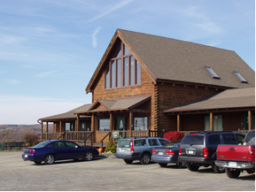New commercial buildings should be compatible with their surroundings. Often “stock” buildings, designed for business use without regard for the site, tend to be imposed on a site, rather than tailored to the site’s strengths and weaknesses. The use of trees and shrubs not only improves the appearance of commercial buildings, but their use also moderates the influence of wind sun, and precipitation. Signs affect the roadside landscape and traffic safety in profound ways.

The Town’s zoning law should provide clear guidance regarding components to be included in site plans, review procedures and site design standards.

The Town’s zoning law should clearly grant authority to enforce conditions of site plan approval and general property maintenance of commercial developments.

Mixed Use Commercial Park Objective: Consider permitting mixed-use commercial / retail / small warehousing park development.

Opportunities to consider include:
- Commercially zoned properties within sewer districts
- Routes 88 / 7 / 20 Intersection
- Rt. 7 / 88 intersection on Schoharie side of town
- Airport site development
- Gage Road / Rt.20 – (Jamaica builders’ location)

Community Development

Goal: To maintain the Town’s rural character, promote the historic cultural heritage of the Town, and enhance community facilities in a cost-effective manner.

Community Facilities and Services Objective: Promote the maintenance, enhancement, and development of community facilities and services that meet the needs of the residents in the most cost-effective way possible.

It is important to the Town’s growth and prosperity that services such as education, police, fire protection, ambulance service, parks and recreation, and highway services be maintained or improved to enhance the town’s quality of life. At the same time, sound fiscal controls should be exercised to keep costs within reasonable limits.

Continue to explore shared service agreements for municipal services such as highway maintenance.

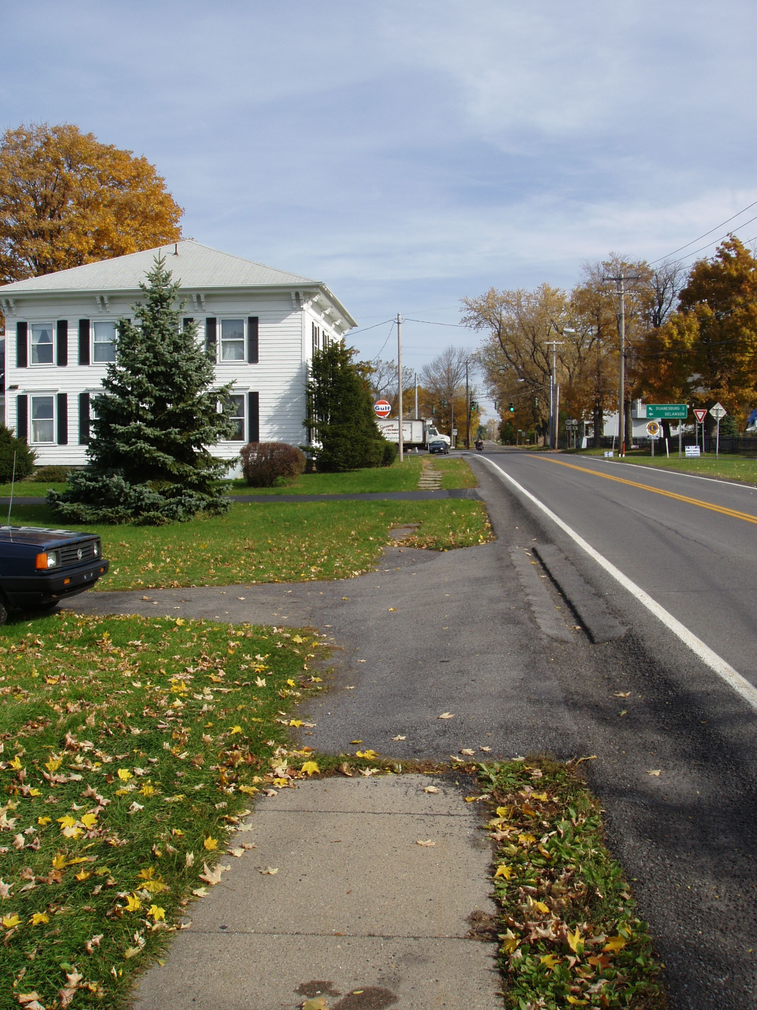Review existing per lot parkland fee for subdivision plats not containing a park for recreational purposes. According to state statute, any monies required by the planning board in lieu of land for park or recreational purposes shall be deposited into a trust fund to be used by the town exclusively for park, playground or other recreational purposes, including the acquisition of property.
- Review existing policies requiring open space fees or setting aside green space for subdivisions. The fees are intended to help maintain open spaces for major subdivision.

Develop a maintenance plan for the Town owned parcel adjoining the County Forest.

Review and update fee schedules for building permits, site plan/special use permit applications, and subdivision applications to ensure that Town review costs are adequate. Clearly identify procedures for supplemental Town engineering review and construction inspection costs to be borne by the developers.

Work with New York State Department of Transportation and local developers to capitalize on opportunities to improve pedestrian accommodations in the Town’s hamlet areas.

Continue to work closely with Village, County, and State construction projects to ensure design and usage is compatible with the surrounding historic neighborhood.

Develop a municipal responsibility and collaboration plan that includes the following categories of priority:

Emergency services – Develop an emergency services continuity and expansion plan for town fire and rescue, ambulance / EMS, and natural disaster response.

Water - Develop a municipal water district proposal to include sole or shared responsibility of the two-existing village of Delanson reservoirs.

Shared Services – Examples include County wide, funding, procurement, and sustainability initiatives (e.g. LED Lighting initiative).

Schools – Initiate and maintain a collaborative relationship with school district leaders / administrators to establish a set of goals and objectives the town officials and school administrators will collaborate to achieve (e.g. town / school community advocacy video and social marketing.

Historic Properties Objective: Encourage the preservation and adaptive reuse of historic properties and context sensitive redevelopment of the Hamlet areas.

The preservation and cultivation of our historic and cultural resources can make a significant contribution toward maintaining a sense of community identity in the face of population growth and new development. Our historic and cultural resources enhance the quality of our lives by providing us with experiences that are otherwise not available. These experiences broaden our background and insight into our past as well as our present.

Require developers to provide appropriate archeological and cultural resource review as recommended by the NYS Office of Parks, Recreation, and Historic Preservation to meet the information requirements of the State Environmental Quality Review Act. New development should limit impacts on historic resources and integrate these features into the site plan as much as possible. Disturbance of cultural and historic resources should be minimized to the greatest extent possible.

New construction in the Town’s Hamlet areas should reflect elements of traditional local architecture and be compatible with adjacent buildings. Building height, design, scale, and mass should be compatible with the surrounding neighborhood.

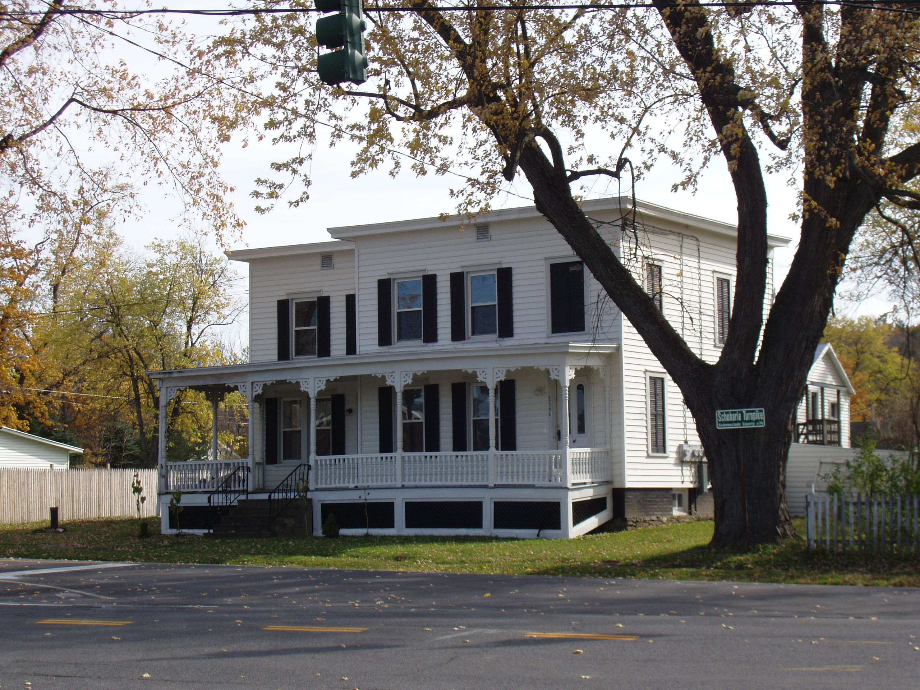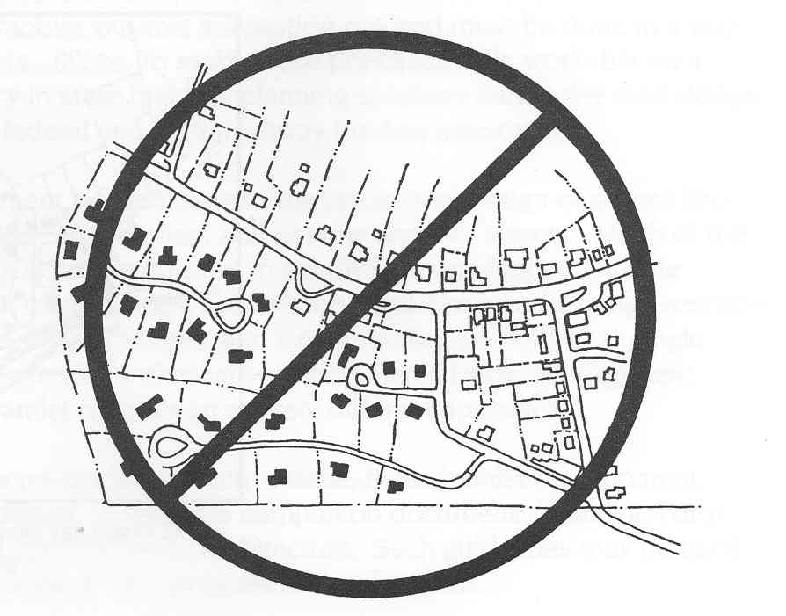The Town’s zoning ordinance should be reviewed for inconsistencies with historic hamlet building design and settlement patterns.

New development in hamlets should extend the existing pattern of small lots, mixed uses, interconnected streets, and walkable neighborhoods.

The Quaker Street Hamlet, with public sewer availability, can accommodate new housing units and businesses without destroying the existing character if new development is consistent with the existing patterns. Large lot, suburban style development disrupts the character of the hamlet and consumes open space.
Avoid Large Lot, Suburban-Style Cul-de-Sac Development of Hamlet Area

Rural Character Objective: Attempt to maintain the Town’s rural character as development occurs.

The results of questionnaires show that an overwhelming majority of town residents support the Town’s land use goal of maintaining a rural atmosphere.

Promote site design that achieves the community goal of maintaining a rural character while allowing landowner flexibility.

Protect roadside views and home sites by encouraging and enforcing new development design layouts that blend into the landscape to the greatest extent possible. Buildings should not protrude over ridgelines or be sited in the middle of open fields. Stonewalls, hedgerows and other rural landscape elements should be retained where practicable.

Avoid fragmentation of core agricultural areas or locating new homes near active farms whenever practical. Homes should be placed at the edges of fields and adequate buffers between new residences and farms should be provided when practicable.

Base residential street widths on intended use and function (i.e. local access street, neighborhood collector). Town road standards should be reviewed and amended as appropriate.

- Develop and/or expand supplementary regulations for uses with unique land use characteristics such as telecommunications facilities, wind turbines, home occupations, etc. to clarify town policies and development standards.

- Support the Duanesburg ‘Night Sky Initiative’ to include the use of down cast lighting, minimal quantities of ‘off hours’ lighting for required safety and security only, and limitations on the brightness of signs. Consider defining guidelines in the Town’s Zoning Ordinance.

Figure 1. Example

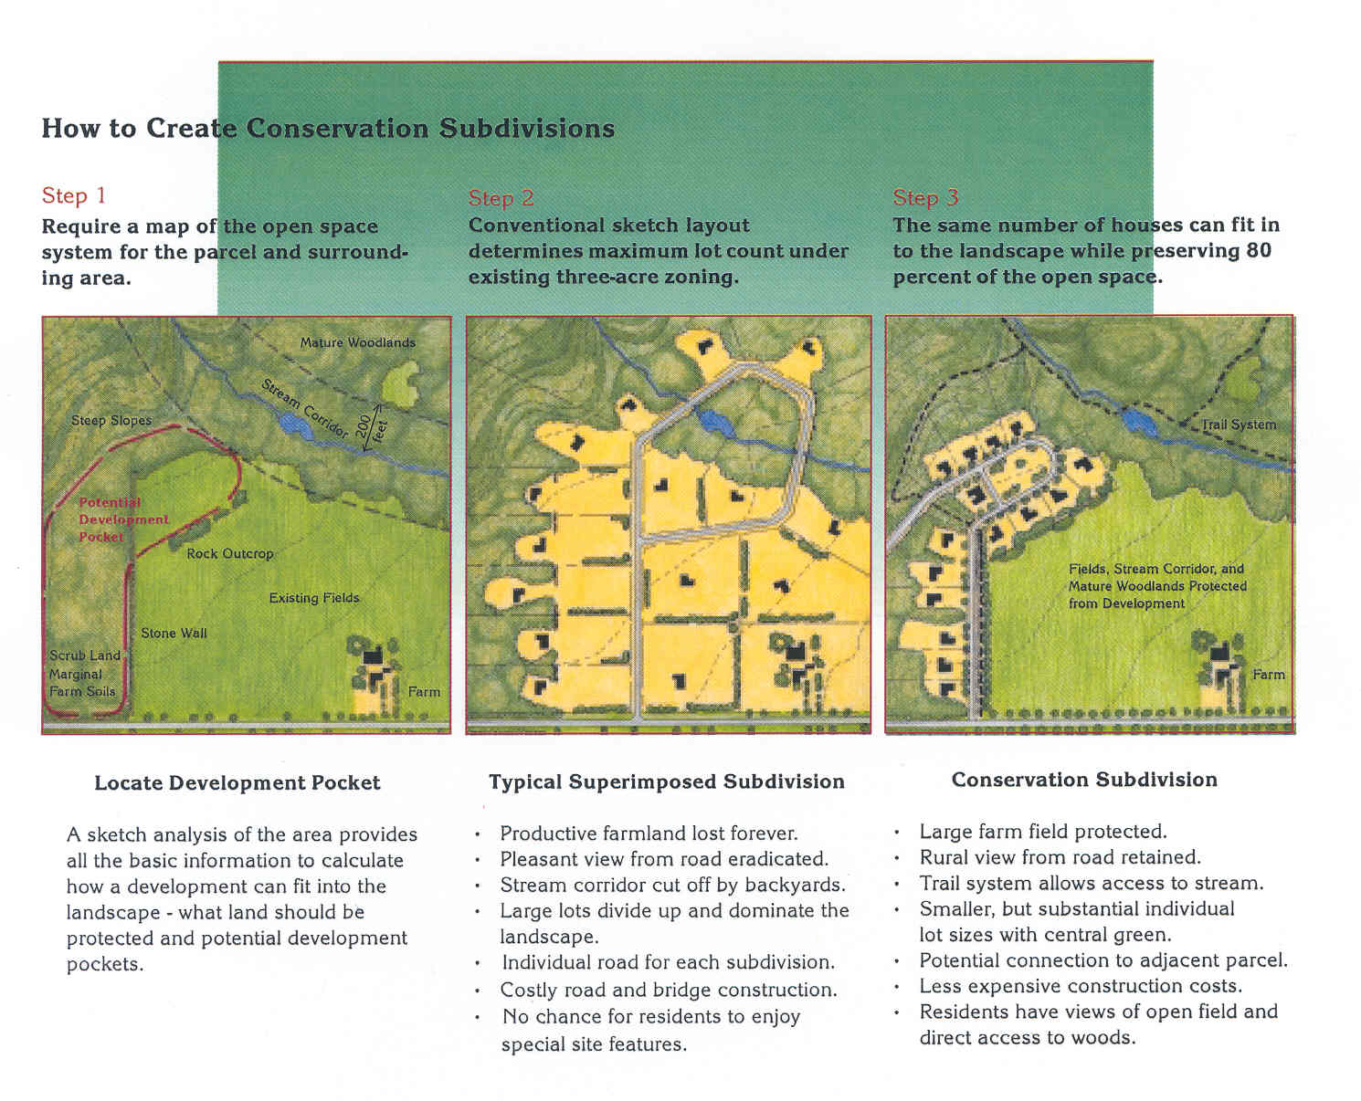
Source: Dutchess County Planning and Development

Goal: Minimize the risk to persons and property from a natural or manmade disaster.

Risk Mitigation Objective: Locate private development, public services, and utilities to minimize the potential risk from a natural or manmade disaster.
- Discourage construction within the FEMA mapped floodplains. Avoid significant increases in stormwater runoff from new development to prevent downstream flooding. Maintain buffers adjoining streams and wetlands to prevent filling due to sedimentation and preserve their capability to absorb and transmit stormwater without adverse impacts. Avoid construction on steep slopes and ensure roadways and driveways can provide adequate emergency vehicle access.

- Consult NYS inundation maps prepared under the emergency action plan for the Gilboa Dam and other local dams when considering land use and development actions.

- Consider the location of natural gas transmission lines or rail lines when locating public parks, senior housing, or other critical facilities. Ensure that any residential development provides adequate separation distance from potential hazards.

Business and Power Continuity Objective: Ensure that critical facilities can continue to operate during a natural or manmade disaster.
- Review and update a plan of action to minimize the potential adverse impacts resulting from loss of power, such as installation of emergency generators, to allow continuation of operations. Develop back-ups or alternatives to provide critical services in the event a building or facility is rendered unusable by a hazard incident through cooperative agreements with adjoining municipalities.
- Consider future development approvals include a requirement to bury utilities.

Natural Resources

Goal: To preserve and maintain the quantity and quality of the Town’s surface and ground water resources, to protect the Town’s soils, agricultural lands, steep slopes, and significant natural areas, and to preserve the health and usefulness of the Town’s forests and wetlands.

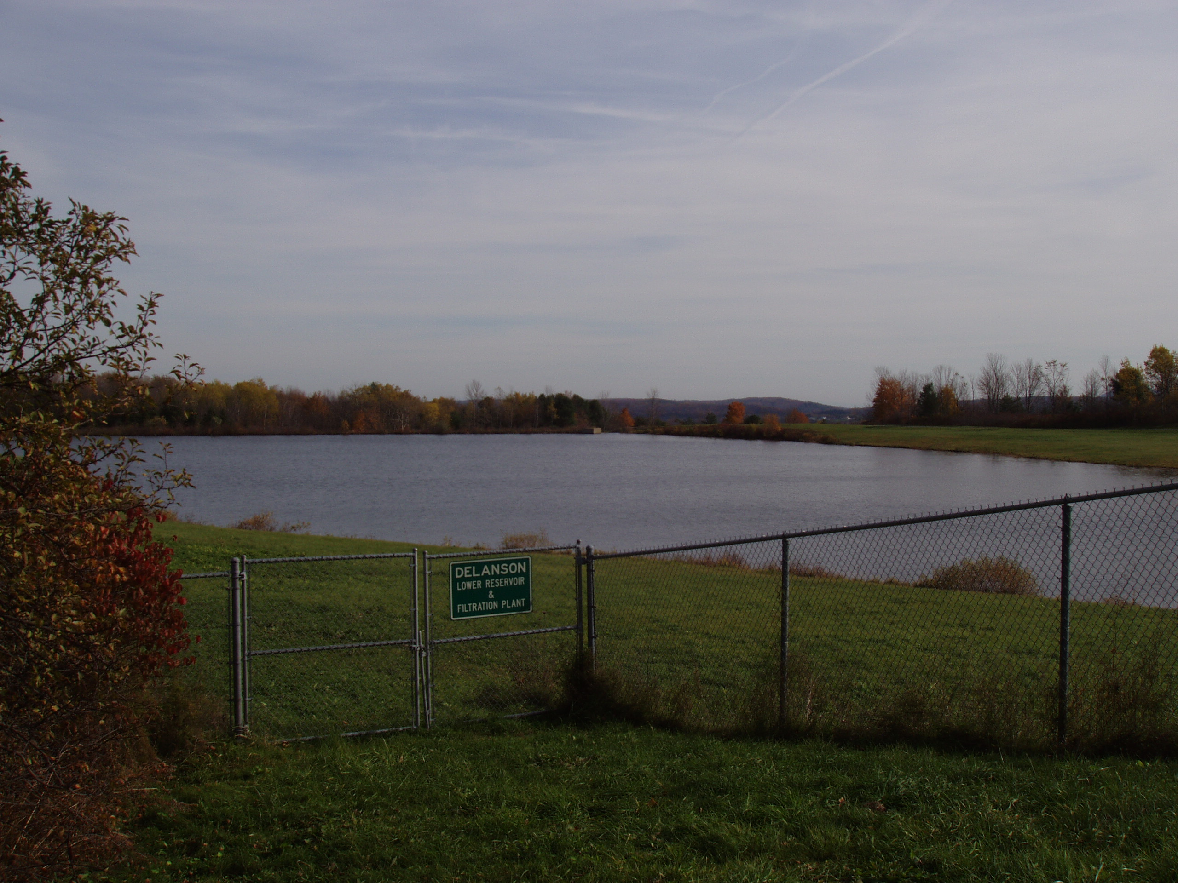

Ground Water Protection Objective: Advocate the use of strict land use controls and development density limits to protect ground water, lake watersheds (Duane, Featherstonhaugh, Mariaville) and the Delanson and Duanesburg reservoir from contamination.

The Town’s ground and surface water are vulnerable to contamination. Industrial waste discharge, road de-icing salts, failing septic system effluent, landfills, leaky petroleum storage tanks, and innumerable household, commercial, and agricultural chemicals can find their way into groundwater and surface water.
Delanson Reservoir

The Town will use permeability, depth, and other soil characteristics to devise basic limits on allowable development density.

Use land use controls to ensure that commercial and industrial facilities are kept away from important water sources.

Work with the Village of Delanson to ensure that development in the Delanson/Duanesburg Reservoir watershed does not negatively impact water quality. Consider adopting additional land use regulations consistent with the Village of Delanson’s proposed rules and regulations to protect the Reservoirs. Consider modifications to the Town’s Zoning Ordinance to define these protections.

Research the feasibility of village owned reservoirs becoming owned, expanded, and responsible by the town.

Research the availability of funding to investigate the feasibility of finding and connecting to other surface water and underground aquifers.

Review and ensure the efficient use of road de-icing salts, sand and other materials used in winter management operations, especially where runoff can easily enter and pollute lakes, waterways, and other fresh watersheds.

Storm Water Runoff Objective: Adopt local measures that prevent increases in storm water runoff volumes and require appropriate erosion and sedimentation control measures as development occurs in accordance with state and federal regulations.

The amount of runoff leaving an area usually increases dramatically as development intensifies. Woodlands, for example, typically intercept 90 percent of the rainfall they receive; the percentage may be lower on steep wooded hillsides and considerably higher in nearly level, dense woods, and highly porous soils. When woodlands are cleared and developed, the amount of rainfall absorbed can drop to less than 10 percent, leaving 90 percent or more to runoff the site. The cumulative results of such increases in runoff volume are usually more serious flooding of downstream land, greater demands on culverts and other drainage system components, and more rapid erosion of stream channels and soils. The conversion of forest to other uses also increases the number of water users while decreasing the amount of open land available to absorb, store, and filter surface and groundwater supplies.

To ensure protection of watercourses from future development, buffer zones and/or minimum building setbacks from streams and creeks should be considered.

Figure 2. Watercourse Buffer

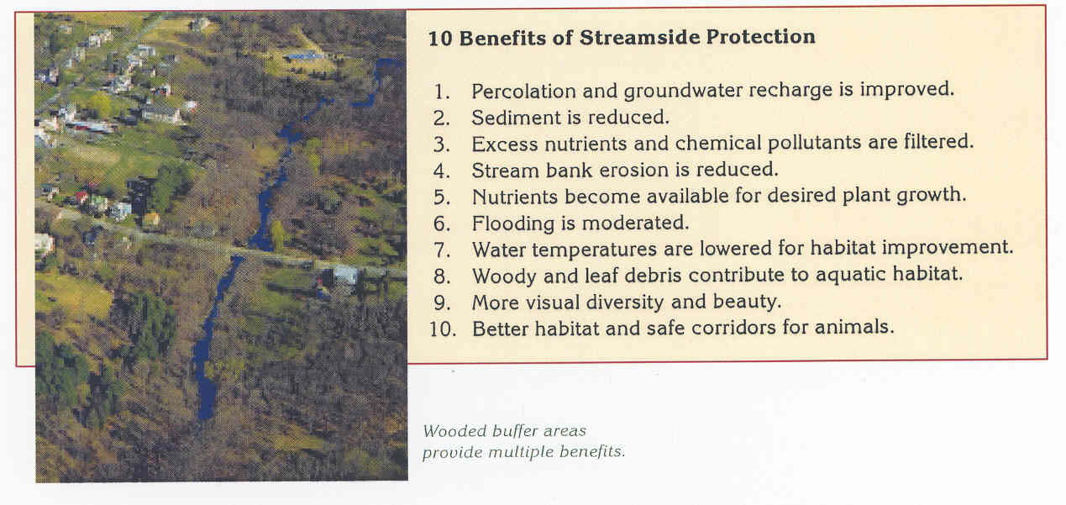
Source: Dutchess County Planning and Development

- Require land development activities to conform to the up-to-date erosion and sedimentation control standards and the substantive requirements of the NYS Department of Environmental Conservation (SPDES) General Permit for Construction Activities GP-02-01 or as amended or revised.

Wetlands Protection Objective: Support efforts to familiarize the public and local officials with wetland values and the rules and regulations governing their disturbance and protect wetlands and their buffers from development activities.

Historically, wetlands have been regarded as wastelands. Recently, however, wetlands have begun to be recognized for the many benefits they provide. Wetlands regulate the quantity and quality of surface and ground water supplies, reduce flood hazards by serving as retention basins for surface runoff, and help maintain water supplies after floodwaters subside. Wetlands also provide critical wildlife habitat and support diverse plant and animal communities. Because of their hydrological characteristics and environmental values, wetlands are not appropriate development sites. State regulated wetlands are surrounded by buffers that offer some protection from the impacts of nearby land use activities. Encroachment on these buffers by disruptive land uses can degrade the wetland quality. The Freshwaters Wetlands Act regulates activities within 100 feet of regulated wetlands.

Support continued wetlands protection by ensuring that development complies with State and Federal wetlands and watercourse protection regulations. Incorporate pertinent state and federal wetlands and watercourse protection regulations by reference into the Town’s zoning and subdivision regulations.

Ensure that wetlands boundaries and watercourses are properly identified during the development review process and that appropriate notice is given to state and federal regulatory agencies.

Ensure that appropriate notations are placed on subdivision plats and within property deeds so that prospective property owners are aware of sensitive natural areas and any development restrictions.

Lake Districts Viability Objective: Encourage the use of special restrictions in the areas around Duane Lake, Featherstonhaugh Lake, and Mariaville Lake to insure the continued viability of these natural resources.

The Town recognizes the environmental and economic value of these water bodies and supports more stringent requirements for development in these areas.

Ensure that the redevelopment or expansion of residences and/or commercial uses in the vicinity of these waterbodies comply with the Public Health Law regarding wastewater treatment and meet up-to-date stormwater management and erosion and sedimentation control standards.

Encourage farms to participate in the State’s Agricultural Environmental Management (AEM) program. The confidential AEM can help farm operations meet environmental and economic goals while benefiting local water quality.

Soils Permeability Objective: Recognize the development limitations of shallow and impermeable soils and ensure that these limitations are given adequate consideration in the development review process.

Soil permeability rates of less than one inch per hour and depths to bedrock of less than three feet impact the development capability of most Duanesburg’s soils. Allowing extensive or improper use of poorly drained, excessively steep, or rocky areas increases the risk of surface/groundwater contamination and soil erosion and can result in high septic system maintenance and repair costs.

- Ensure that development complies with the Public Health Law with regard to wastewater treatment and conforms to up-to-date erosion and sedimentation control standards and the substantive requirements of the NYS Department of Environmental Conservation (SPDES) General Permit for Construction Activities GP-02-01 or as amended or revised.

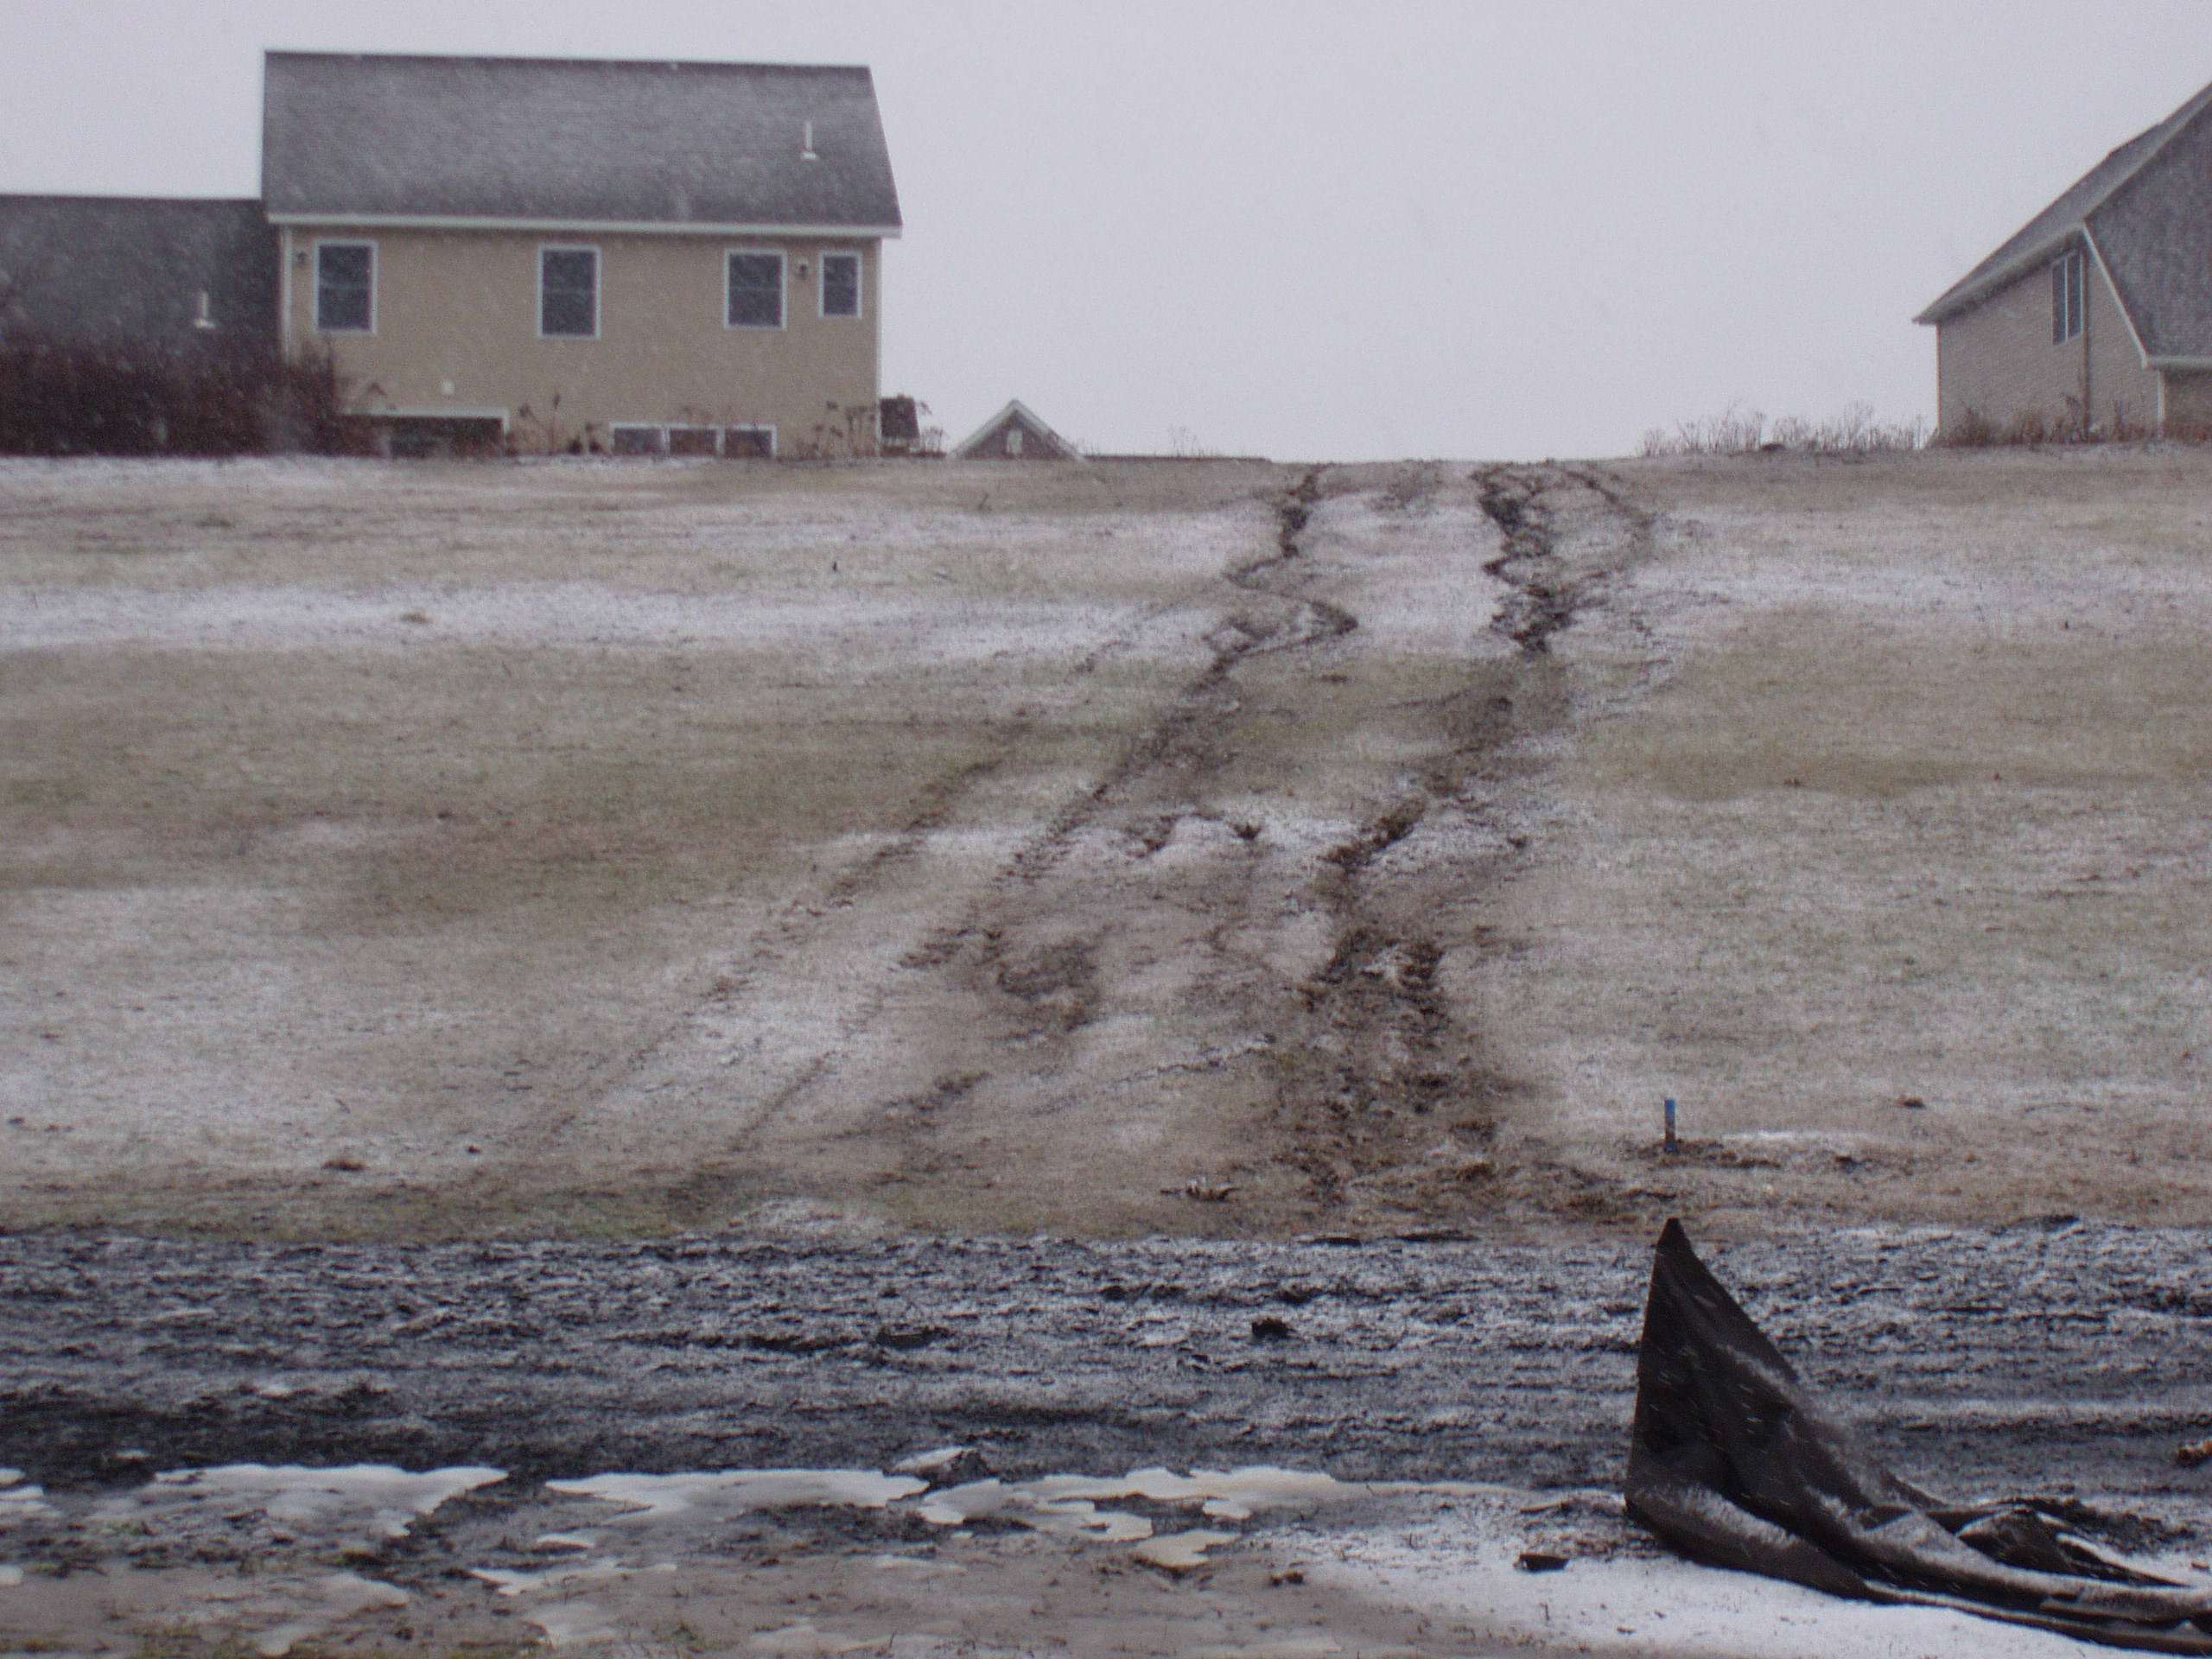Ensure that adequate on-site soils investigation work (depth to bedrock, soil classification, topography) for septic systems and water supply are performed prior to approval of major subdivisions or commercial development.

Erosion Control Objective: Adopt measures to limit erosion from construction sites, unpaved roads and shoulders, and other areas where soil is exposed or disturbed.

Incorporate up-to-date erosion and sedimentation control standards in the Town’s building regulations and subdivision and zoning codes.

Ensure that developers are aware of, and abide by, the new state stormwater and erosion control requirements.

Soil Erosion Due to Lack of Appropriate Stabilization Techniques

Steep Slopes Preservation Objective: Preserve steep slopes and ridgelines.

Development constraints increase as slope increases. Slopes of 5 to 15 percent generally place moderate limitations on land use. Slopes of more than 15 percent are considered severe development constraints for three reasons: steep slopes shed more surface water at higher velocity; steep slopes tend to be covered by shallow soils which cannot filter septic wastes properly; and steep slopes are expensive to develop. Slopes over 25 percent should not be developed.

Consider establishing steep slope development restrictions in the Town’s zoning and subdivision regulations. Consider modifying the Town’s Zoning Ordinance to define these restrictions

Forest Resources Objective: Encourage protection and recognition of uncommon or especially sensitive forest resources and the woodland buffers around water bodies, wetlands, and roadways.

Less common forest communities have aesthetic and wildlife habitat values that should be preserved for future generations.

Consider incorporating cluster and conservation development provisions into the Town’s subdivision regulations to help preserve significant environmental features.

To ensure protection of watercourses from future development, buffer zones and/or minimum building setbacks from streams and creeks should be considered. Driveway and road crossings of watercourses should be avoided where practicable.

Work with private organizations such as the Mohawk-Hudson Land Conservancy, Open Space Institute, and The Nature Conservancy to secure important natural areas and working landscapes through conservation easement donations or outright purchase. Local examples include the Nature Conservancy’s Christman Sanctuary.
- Develop and enforce a clear cutting forestry practices permit process that restricts the clearing of large tracts of land for the purpose of minimizing erosion control, preserving the towns valuable forest cover and protecting designated Critical Environmental Areas (CEA’s) and wildlife habitat ecosystems.
- Monitor NYS Environmental Conservation efforts to track the impact of the Emerald Ash Borer, Spotted Lantern Fly, Asian Long Horn Beetle, Oak Wilt, Hemlock Wooly Adelgid , and other invasive species. Harvesting of the hardwoods potentially subject to impact by these species should be encouraged. Harvesting of these trees eliminates potential homes for these species and could create income for landowners. The Town should review their own properties to determine if any of these trees should be harvested from their own land.

ADMINISTRATION

Goal: Improve the administration, implementation, and enforcement of land use regulations.

Training and Access Objective: Ensure proper training and access to pertinent information for zoning and planning officials.

Continue the existing policy with the County Department of Economic Development and Planning to organize training workshops for planning and zoning board members, building inspector, and town planner.

Provide monies in the Town budget to reimburse town officials for attending local training sessions.

Continue to provide access to zoning and subdivision regulations on the Town’s web site

Continue to utilize the County’s web-based Geographic Information System (SIMS) to ensure access to mapped resource data.

Application and Enforcement Objective: Ensure consistent application and enforcement of zoning regulations.

Amend zoning and subdivision regulations so that they are more easily understood, well-defined and consistent with the Comprehensive Plan.

Review and update building/subdivision application forms and fees as appropriate.
- Prioritize the enforcement and resolution of "Zombie Mortgage” and Abandoned Properties. (Properties damaged by Fire and flooding)

INFRASTRUCTURE

Goal: Grow and continuously improve the towns infrastructure availability, capacity, and quality.

Sewer Districts Objective: Every effort should be made to provide sewer in areas that are vulnerable to concentrated effluent.

Prioritize the town’s lake districts and any other area where home / business density warrants it, and funding is potentially available.

Proactively obtain grant funding for future expansions of existing sewer districts and development of new necessary sewer districts for the purpose of maintaining costs within an affordable range for the impacted residents.

Broadband Objective: Every effort will made to provide broadband access to every home and business in town, with a minimum speed of 100mbps.
- ~217 homes in the town need access to broadband as of February 2020.
- Secure grant funding from County, State, and/or Federal governments with the purpose of connecting the many of the unserved homes in town located in remote areas.
- Consider prioritizing businesses in commercial districts, home based businesses, and homes with school age children without access.

Roads and Highways Objective: The highway department will be funded to ensure that all town roads are maintained in a manner to maximize safety and minimize long term costs.
- The highway winter fund will enable the highway department to plow / manage every affected town road within a 4-hour cycle time at the end of any icing event or a snowfall that exceeds 3 inches.
- The highway department will be funded to support required optimization of equipment and materials for the purpose of minimizing non-point source runoff of products (salt, sand, asphalt) and maximizing efficiency opportunities to control and reduce costs.

Municipal Water Access Objective: Provide a municipal water source, particularly for areas of the town targeted for commercial or dense residential growth.
- Secure initial funding to employ a needs assessment
- Employ a needs assessment to identify the costs and logistics for providing municipal water to other parts of town. However, the town should be alert for any State initiatives or funding that might facilitate such a system, in addition to any aid that Metroplex could provide, that might make such a system more affordable, especially in areas of town targeted for business development
- Research the feasibility of the Town owning, expanding, and absorbing responsibility for the village owned reservoirs.
- Secure a larger set of funding, should a needs assessment identify the capability and cost for developing a town municipal water source.

Municipal Electricity Objective: Provide a municipal electricity, and renewable energy (solar) source, that optimizes the town’s owned land availability.

- Conduct a feasibility study to determine options available and to determine initial costs for the town to generate its own solar electric power. Power grid access and capacity are the two major concerns for determining feasibility. Presently, the National Grid subsystem in town does not have any available room for the Town to hook any potential solar power generation into.

Trash & Recycling Objective: Provide the most affordable, responsible, and consolidated trash and recycling solution option that allows each business and residential home to contract for individual service.
- Consider first conducting an interest survey of town businesses and residents
- If survey interest is positive, then perform a cost comparison / cost benefit analysis
- Consider developing a specification and request for proposal (RFP) from local trash / recycling providers

LAND USE PLAN

The Town is currently divided into seven zoning districts:

R-1 - Residential Higher Density – Lots 1 –1.5 acres

R-2 - Rural Residential / Agricultural

H - Hamlet – Mixed Use Residential / Commercial

C-1 - Commercial

C-2 - Commercial & Light Industrial

L-1 - Lake

MP - Mobile Home Park

It is recommended that the number and names of the districts remain the same with exception of a potential C-3 District detailed earlier in this document. Policy changes to zoning laws and development review procedures should be implemented as discussed in the Goals, Objectives, and Recommendations section of this Plan. Descriptions of the existing zoning districts appear below.

R-1 HIGHER DENSITY RESIDENTIAL DISTRICT

Approximately 250 acres in two areas of Town are zoned R-1. One area is along Cole Road between the Village line and State Route 7. The other area is east of the Quaker Street Hamlet around the State Route 7 and East Shore Road intersection. This zone is located entirely within the sewer district. Existing land use in this district consists primarily of single-family residences. The Duanesburg Elementary School and a Town Park (Shafer Park) are also located within this district. There are a few larger, vacant parcels that may have some development potential.

R-2 AGRICULTURAL & RESIDENTIAL DISTRICT

Most of the Town is currently zoned R-2 reflecting the predominantly rural residential/agricultural nature of the community. Land in this district consists of various types of soil conditions. Areas of steep topography are found as well as areas of surface bedrock conditions. The predominant limitation on development is the poor suitability of the soils for septic systems and lack of potable water. Soil characteristics may severely limit the use of conventional on-site septic disposal systems.

Existing land use in this district consists of scattered single-family residences and agricultural operations. Land use in this district should emphasize the preservation of agricultural soils and viable agricultural operations. Rural residential/agricultural uses can be developed at a low density that matches the carrying capacity of the soils and environmental limits of the location. Strong ground water protection measures are required.

Residential uses should continue to be allowed at an overall density of one single-family dwelling per 2.3 acres. Conservation subdivisions should be encouraged to preserve rural character.

H: HAMLET DISTRICT

Four areas of the Town are zoned as hamlet districts: the hamlet of Mariaville in the area adjacent to Mariaville Lake; the hamlet of Duanesburg in the area adjacent to the intersection of Routes 7 and 20; the hamlet of Quaker Street adjacent to the intersection of Routes 7 and 395, and the hamlet of Braman Corners at the intersection of Braman Corners Road, State Route 30, and Millers Corners Road. These areas as so designated because of the role they have played in the development of the Town. These hamlets serve as centers of residential and commercial uses and provide a comfortable relationship between residential and non-residential uses.

These hamlet areas should continue as focal points of community activity and development. Development and redevelopment should be allowed in the hamlets at a size and scale appropriate to and complementing the historic character of these areas. Permitted activity in this district would include residential and civic uses which are compatible with the existing hamlet.

Development in the hamlet district will be limited by the availability of water, sewer, and the ability of soils to handle on-site septic systems. Expansions of the hamlets could be contemplated where suitable soil conditions and public sewer is available.

L-1: LAKE DISTRICT

Two areas of town surrounding Mariaville Lake and Duane Lake comprise the Lake District. The Lake Districts are almost completely developed with single family residences. Most lots are pre-existing nonconforming in size with limited subdivision possibility. The Mariaville Lake District has public sewer. Duane lake properties are serviced by private septic systems. Alternatives for a potential public sewer system for the residences surrounding Duane Lake are currently being investigated.

C-1: COMMERCIAL BUSINESS DISTRICT

The existing Commercial Districts are concentrated along State Route 20 and State Route 7. They generally encompass existing business development and are located at highway intersections and other nodes of activity. Much of the Commercial District is currently vacant or in agricultural use providing ample acreage to accommodate business development. Certain areas are predominantly occupied by single family dwellings since they are a permitted use by special use permit. In areas of Commercial Districts dominated by single family dwellings, consideration should be given to rezoning the property to accurately reflect existing land use.

Identify areas where commercial district properties should remain commercially zoned and restrict future residential special use permits. This should be revisited during the next Zoning Ordinance review.

Adequate land is set aside to meet the business and commercial needs of the community. However, depending upon the proposed use and location, commercial development may be limited due to the lack of public sewer and water.

The clustering of commercial activity in the Town is important for safety and community character reasons. Concentrated commercial areas minimize traffic conflicts on Route 7, 20, and 30, the three roads with highest volume of traffic in the Town.

C-2: MANUFACTURING & LIGHT INDUSTRIAL DISTRICT

Historically, there has been little or no demand for industrial land in the Town. The lack of central water and sewage systems are factors that discourage industry from locating in the Town. Therefore, the Town must provide the potential for this type of development.

There are approximately 470 acres around the I-88 exit 24 interchange and the Duanesburg Hamlet area zoned C-2. One other 88-acre parcel at the intersection of Route 20 and Gage Road, developed as a building supply warehouse, is also zoned C-2. The C-2 zone is predominantly vacant or agricultural property. Like the C-1 District, some parcels have been subdivided for single family dwellings.

The principal difference between the C-1 and C-2 zones is C-2 allows Manufacturing and Light Industrial uses and warehousing and storage units. According to the household survey, 70 percent of respondents indicated that commercial and light industrial uses should be encouraged as land uses. Conversely, 91 percent said the Town should discourage heavy industry. Consider modifying the Zoning Ordinance to specifically disallow heavy industry.

Given the prominent location of the C-2 District, proposed uses will need to be reviewed carefully. As with the C-1 District however, commercial development may be limited due to the lack of public sewer and water.

Small industries can blend harmoniously into rural landscapes by carefully applying site plan and performance standards. Adequate acreage appears to be available to accommodate such uses. However, additional areas should be considered for small industrial enterprises if appropriate site plan and performance standards are met.

C-3: Consider the creation of this new district which would permit warehouses larger than presently permitted in the existing commercial districts. The thinking here is that continued adoption of internet-based commerce, and the additional impact of the COVID-19 crisis, has significantly shifted economic activity from brick and mortar retail to on-line sources. The Town possesses a great asset that could enable it to participate in this dynamic economic shift. That asset is an Interstate Highway exit and its proximity to vacant land. Larger distribution warehouses with direct on-off Interstate Highway access could provide the Town with a significant increase in tax revenue and the creation of numerous local employment opportunities. All without having any impact on local traffic activity.

MP: MOBILE HOME PARK DISTRICT

Housing alternatives must be available to meet the diverse needs of the Town’s residents. Well designed and maintained mobile home parks provide an affordable housing alternative for many residents.

A mobile home park district is located on Route 20 just east of the I-88 interchange

ENVIRONMENTAL OVERLAY DISTRICTS

An overlay district is the superimposing of an additional set of regulations on a specific area without regard to existing zoning district boundaries. The new regulations apply in addition to the existing provisions of the zoning law.

Overlay zones create a framework for conservation or development of special geographic areas. Overlay provisions typically impose greater restrictions on the development of the land to protect an identified natural resource. Their purpose is to conserve natural resources without unduly disturbing the expectations created by the existing zoning law. The existing zoning provisions may properly regulate the relevant district in general but more specific provisions may be needed to accomplish pressing land use objectives.

Priority should be given to adopting an overlay district for the Delanson/Duanesburg watershed to provide additional protections to the water supply. Additional overlay districts could be considered for Mariaville, Featherstonhaugh and Duane Lake watersheds that could qualify as DEC recognized Critical Environmental Areas (CEA’s), although it should be noted that Mariaville and Duane Lakes are surrounded by private properties and as such, are not directly managed by the Town.

MAJOR SOLAR FACILITIES

The Town Board enacted a six-month moratorium on new major solar facilities. This moratorium was requested by Town residents who were concerned regarding the numbers and locations of major solar facilities in the Town. Due to the COVID-19 pandemic the moratorium was extended for an additional six months by the Town Board. During the moratorium and prior to the moratorium, suggestions have been made for improvement of the solar law as applied to major solar facilities. The Town Board is in the midst of gathering public feedback through a series of meetings on the existing solar law. The goal of the Town Board is to evaluate the solar law and to determine how best to protect the rural character of the town.

IMPLEMENTATION

The Comprehensive Plan by itself does not change the Town’s zoning law, subdivision ordinance, or other land use controls nor does it ensure the implementation of the recommendations contained in the Plan. Instead, the Comprehensive Plan provides the rational basis to update the zoning and subdivision laws, provides guidance on capital expenditures, and identifies the goals, objectives, and policies for the immediate and long-range protection, enhancement, growth, and development of the Town.

While the Town will make important decisions on the location of utilities, parks, and other public facilities, the vast majority of development in Town is carried out by private individuals and organizations—whether it is a landowner seeking to subdivide the family farm or a business seeking a new location to expand. Therefore, it is private actions that will ultimately drive community development, that are guided, and regulated by the Comprehensive Plan and Town laws.

While the Town cannot force a private individual to develop a property for a particular use, where there is a good Comprehensive Plan followed and updated on a continuing basis, a reliable foundation for private investment can be created. This encourages good development and can help accomplish many of the recommendations in the Comprehensive Plan. Similarly, while it may not be possible to legislate “good design,” clear development standards will establish clear expectations and form the basis for well-reasoned decisions. Such standards and guidelines will give the responsible board the authority and knowledge necessary to steer an applicant’s design in the direction the Town wishes to go as articulated in the Comprehensive Plan. Possibly more importantly, the standards will clearly articulate land development options that a landowner/developer can pursue aside from a typical subdivision. Providing guidance on preferred development alternatives and articulating design options is important since voluntary actions by landowners will be critical to the future built environment of the Town.
Providing guidance on preferred development alternatives and articulating design options is important since voluntary actions by landowners will be critical to the future built environment of the Town.

Once the Comprehensive Plan is adopted by the Town Board, there are many strategies that can be used to implement it. One of the most important actions is to amend the Town’s Zoning Ordinance and Subdivision Regulations to incorporate changes recommended in the Comprehensive Plan. As a first step toward implementation, the Town Board should appoint a committee to revise these regulations. An expected goal is to have any new zoning law and subdivision regulations in place one year after adoption of the Comprehensive Plan.
One of the most important implementation actions is amending the Town’s zoning ordinance and subdivision regulations.
Secondly, the Town should seek grants to provide supplemental studies of issues not fully explored in the Comprehensive Plan. These include sewer and water infrastructure needs, open space/recreation, and hamlet development issues. Monies are available through the Capital District Transportation Committee’s Community and Transportation Linkage Program; New York State Department of State Quality Communities Program, Division of Housing and Community Renewal Main Street Program; New York State Community Development Block Grant Small Cities Program; Office of Parks, Recreation and Historic Preservation Environmental Protection Fund; US Department of Agriculture New York Rural Development Program; federal highway enhancement program (SAFETEA-LU); and others. The Town should work with the County and other governmental agencies to continuously explore grant opportunities.

Review and Revision Recommendations

It is recommended the Planning Board and the Zoning Board of Appeals review any zoning rules that may need to be revised based on this comprehensive plan update, and so that additional review of special use permits is not required for specific areas. The recommendations for these revisions will be provided to the Town Board.

Consider if the zoning plan / zoning areas need to be updated to reflect prioritization of different land uses.

Recommend necessary changes of the solar law to the town board.

Ensure that the Zoning Map is updated and provided to the Town Board for review and approval.

Finally, it is recommended the Town, Planning and Zoning Boards individually conduct a review of this comprehensive plan update periodically to ensure it accurately reflects the Town’s current goals and policies. Future amendments can be accomplished by resolutions, studies, reports, or other descriptive materials that may be adopted as part of the Comprehensive Plan, or through a comprehensive revision process that occurred for this update. Additionally, the plan should be reviewed to reflect any new census statistics that become available every ten years.

Appendix A

Household Survey Results
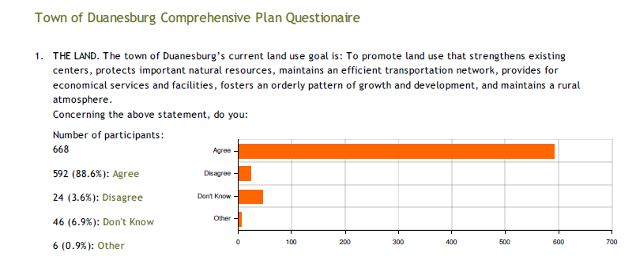

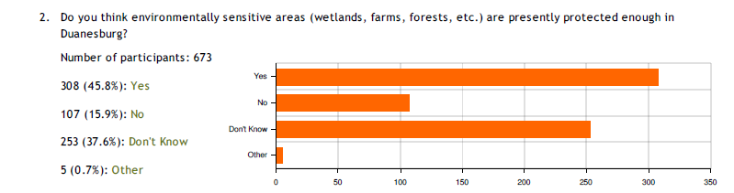

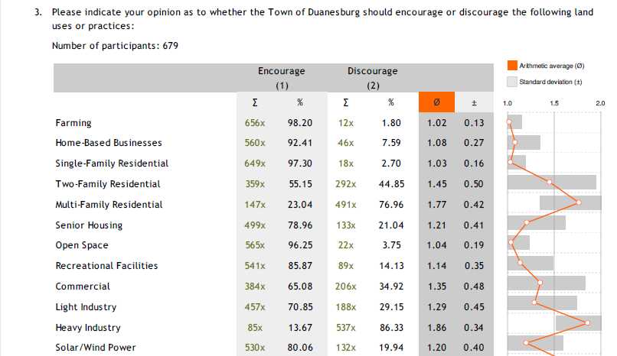
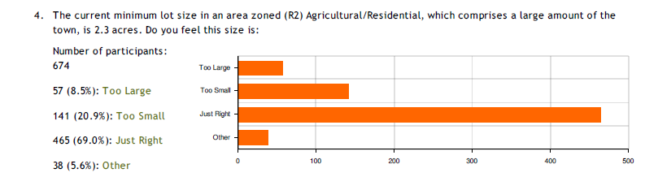

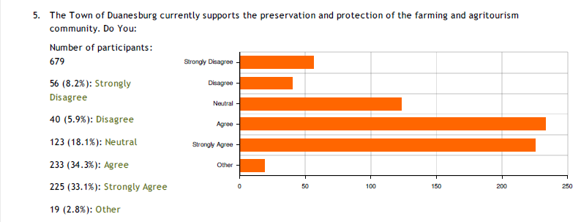

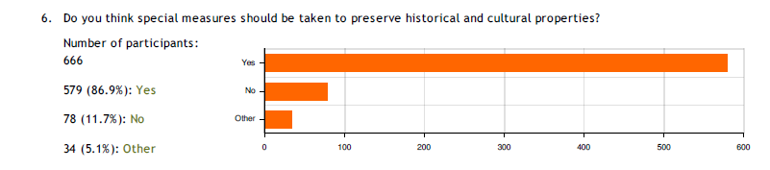

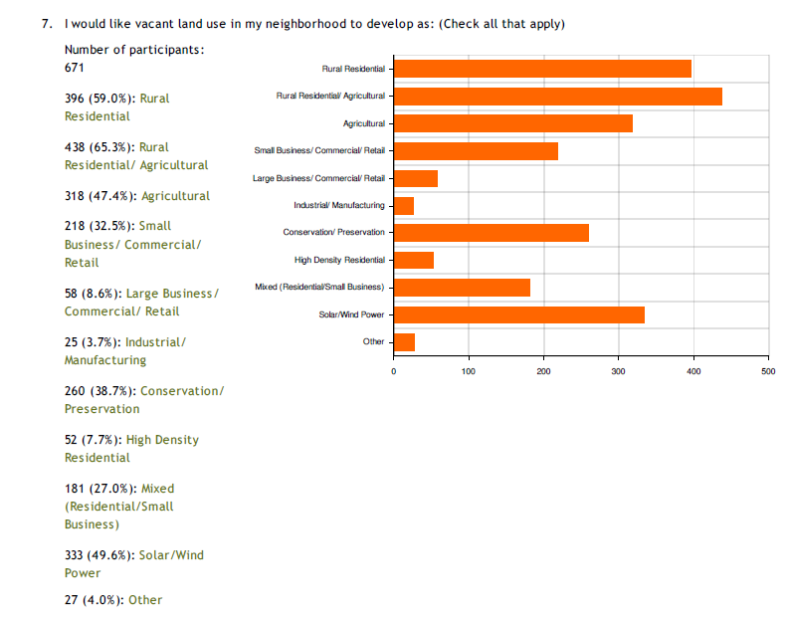

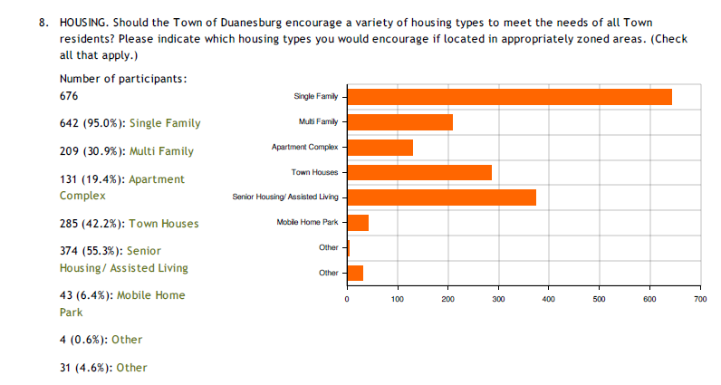

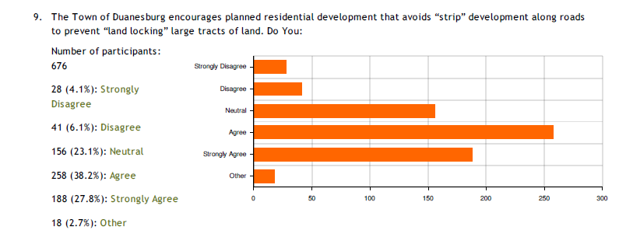

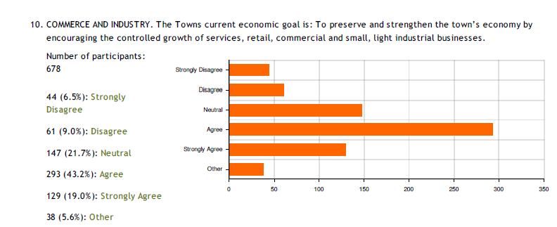

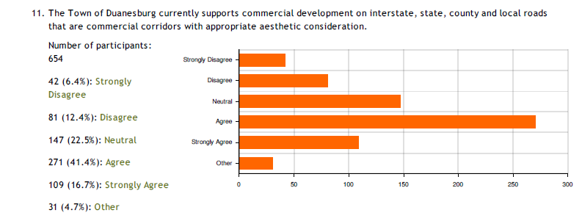

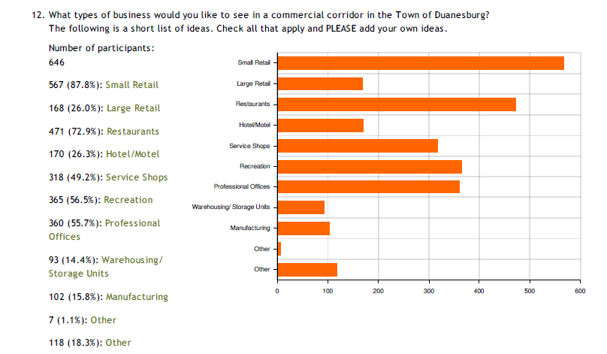
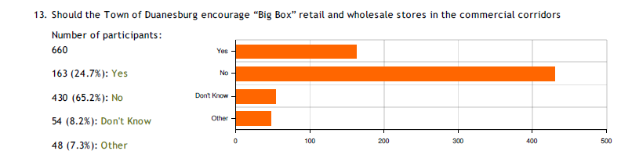
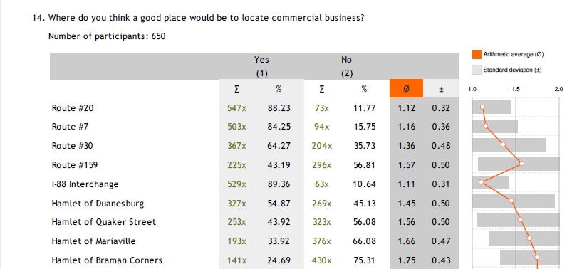

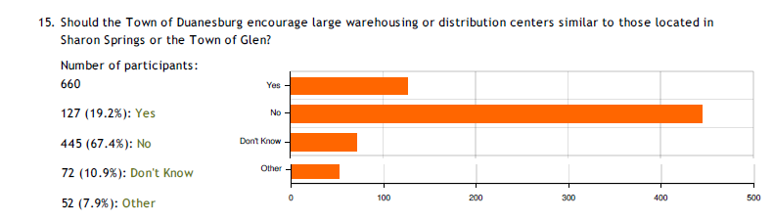

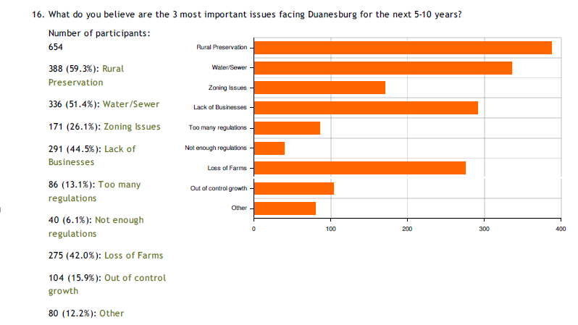

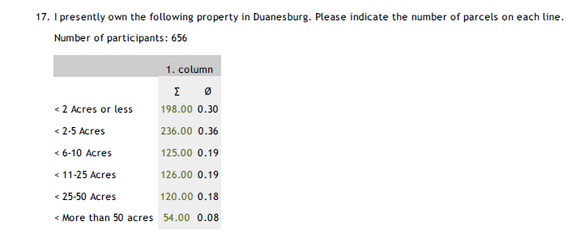
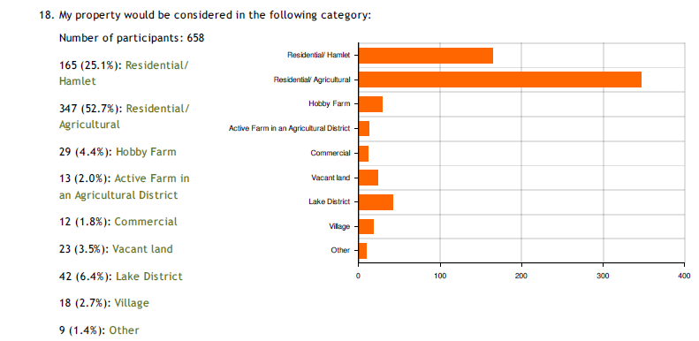

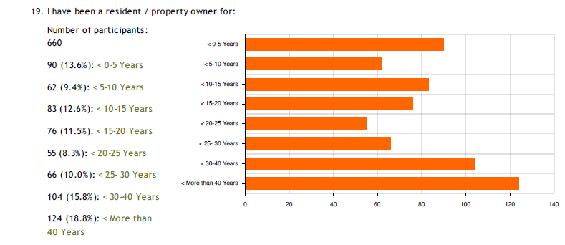

Appendix B

Public Hearing Comments

